UNIT-I
IntroductiontoComputerNetworks
  - Data Communication: When we communicate, we are sharing information. This sharing can be local or remote. Between individuals, local communication usually occurs face to face, while remote communication takes place over distance.

Components:
A data communicationssystemhasfive components.
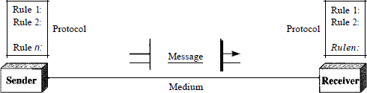

- Message. The message is the information (data) to be communicated. Popular forms of information include text, numbers, pictures, audio, and video.
- Sender. The sender is the device that sends the data message. It can be a computer,workstation, telephone handset, video camera, and so on.
- Receiver. The receiver is the device that receives the message. It can be a computer, workstation, telephone handset, television, and so on.
- Transmission medium. The transmission medium is the physical path by which a message travels from sender to receiver. Some examples of transmission media include twisted-pair wire, coaxial cable, fiber-optic cable, and radio waves
- Protocol. A protocol is a set of rules that govern data communications. It represents an agreement between the communicating devices. Without a protocol, two devices may beconnected but not communicating, just as a person speaking French cannot be understood by a person who speaks only Japanese.

Data Representation:

Informationtodaycomesindifferentformssuchastext, numbers,images,audio,andvideo.
Text:
In data communications, text is represented as a bit pattern, a sequence of bits (Os or Is). Different sets of bit patterns have been designed to represent text symbols. Each set is called a code, and the process of representing symbols is called coding. Today, the prevalent codingsystem is called Unicode, which uses 32 bits to represent a symbol or character used in any language in the world. The American Standard Code for Information Interchange (ASCII), developed some decades ago in the United States, now constitutes the first 127 characters in Unicode and is also referred to as Basic Latin.
Numbers:
Numbers are also represented by bit patterns. However, a code such as ASCII is not usedtorepresentnumbers;thenumberisdirectlyconvertedtoabinarynumbertosimplify mathematical operations. Appendix B discusses several different numbering systems.
Images:
Images are also represented bybit patterns. In its simplest form, an image is composedofa matrix of pixels (picture elements), where each pixel is a small dot. The size of thepixeldepends on the resolution. For example, an image can be divided into 1000 pixels or 10,000pixels. In the second case, there is a better representation of the image (betterresolution), butmore memory is needed to store the image. After an image is divided into pixels, each pixel is assigned a bit pattern. The size and the value of the pattern depend on the image. For an image made of only blackand- white dots (e.g., a chessboard), a I-bit pattern is enough to represent a pixel.Ifanimage is notmade of purewhiteandpure black pixels,youcanincrease thesize of the bit pattern to includegray scale.For example,to showfour levels ofgray scale,youcan use 2-bit patterns. A black pixel can be represented by 00, a dark gray pixel by 01, a lightgray pixelby10, and a white pixel by11. There are several methods to represent color images. One method iscalledRGB, socalledbecause each color ismade ofa combinationofthree primary colors: red, green, and blue. The intensity of each color is measured, and a bit pattern is assigned to it. Another method is called YCM, in which a color is made of a combination of three other primary colors: yellow, cyan, and magenta.
Audio:

Audio refers to the recording or broadcasting of sound or music. Audio is by nature different from text, numbers, or images. It is continuous, not discrete. Even when we use a microphone to change voice or music to an electric signal, we create a continuous signal. In Chapters 4 and 5, we learn how to change sound or music to a digital or an analog signal.
Video:
Video refers to the recording or broadcasting of a picture or movie. Video can either be producedasacontinuousentity (e.g.,by aTVcamera),or itcanbeacombinationofimages, each a discrete entity, arranged to convey the idea of motion. Again we can change video to a digital or an analog signal.

DataFlow
Communicationbetweentwodevicescanbesimplex,half-duplex,orfull-duplexasshownin Figure
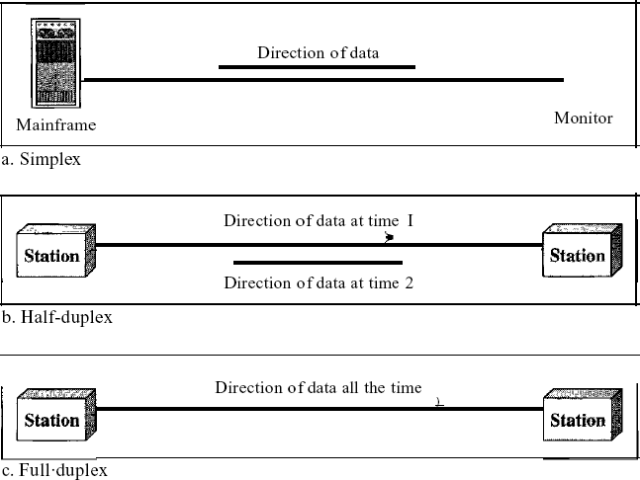

Simplex:
Insimplexmode, thecommunicationisunidirectional, ason aone-way street.Only one of the twodevices ona link cantransmit;the othercanonly receive (see Figurea).Keyboards andtraditionalmonitorsareexamplesofsimplexdevices.Thekeyboardcanonly introduce input; the monitor can only accept output. The simplex mode can use the entire capacity of the channel to send data in one direction.
Half-Duplex:
In half-duplex mode, each station can both transmit and receive, but not at the same time. When one device is sending, the other can only receive, and vice versa The half-duplex mode is like a one-lane road with traffic allowed in both directions.
When cars are traveling in one direction, cars going the other way must wait. In a half-duplex transmission, the entire capacity of a channel is taken over by whichever of the two devices is transmitting at the time. Walkie-talkies and CB (citizens band) radios are both half-duplexsystems.
The half-duplex mode is used in cases where there is no need for communication in bothdirections at the same time; the entire capacity of the channel can be utilized for each direction.
Full-Duplex:
In full-duplex both stations can transmit and receive simultaneously (see Figure c). The full-duplex mode is like a tW<D-way street with traffic flowing in both directions at the same time. In full-duplex mode, si~nals going in one direction share the capacity of the link: withsignals going in the other din~c~on. This sharing can occur in two ways: Either the link must contain two physically separate t:nmsmissiIDn paths, one for sending and the other for receiving; or the capacity of the ch:arillilel is divided between signals traveling in both directions. One common example of full-duplex communication is the telephone network. When two people are communicating by a telephone line, both can talk and listen at the same time. The full-duplex mode is used when communication in both directions is required all the time. The capacity of the channel, however, must be divided between the two directions.

NETWORKS
A network is a set of devices (often referred to as nodes) connected by communication links. A node can be a computer, printer, or any other device capable of sending and/or receiving data generated by other nodes on the network.

DistributedProcessing
Most networks use distributed processing, in which a task is divided among multiple computers. Instead of one single large machine being responsible for all aspects of a process, separate computers (usually a personal computer or workstation) handle a subset.

NetworkCriteria
Anetworkmustbeabletomeetacertainnumberofcriteria.Themostimportantoftheseare performance, reliability, and security.
Performance:
Performance can be measured in many ways, including transit time and response time.Transit time is the amount of time required for a message to travel from one device toanother.Response time isthe elapsedtimebetween aninquiry andaresponse. The performance of a network depends on a number of factors, including the number of users, the type of transmission medium, the capabilities of the connected hardware, and the efficiency of the software. Performance is often evaluated by two networking metrics: throughput and delay. We oftenneedmorethroughputandlessdelay.However,thesetwocriteriaareoftencontradictory. If we tryto send more data to the network, we may increase throughput but we increase the delay because of traffic congestion in the network.
Reliability:
In addition to accuracy of delivery, network reliability is measured by the frequency of failure, the time it takes a link to recover from a failure, and the network's robustness in a catastrophe.
Security:
Network security issues include protecting data from unauthorized access, protecting data from damage and development, and implementing policies and procedures for recovery from breaches and data losses.

Physical Structures:
Type ofConnection
A network is two or more devices connected through links. A link is a communications pathway thattransfersdatafrom onedevicetoanother.For visualizationpurposes,itissimplest toimagineany linkasalinedrawnbetweentwopoints.Forcommunicationtooccur,two devices must be connected in some wayto the same link at the same time. There are two possible types of connections: point-to-point and multipoint.
Point-to-Point
A point-to-point connection provides a dedicated link between two devices. The entire capacity of the link is reserved for transmission between those two devices. Most point-to-point connections use an actual length of wire or cable to connect the two ends, but other options, suchas microwave or satellite links, are also possible.Whenyouchange television channels by infrared remote control, you are establishing a point-to-point connection between the remote control and the television's control system.
Multipoint
A multipoint (also called multidrop) connection is one in which more than two specific devices share a single link. In a multipoint environment, the capacity of the channel is shared, either spatiallyor temporally. If several devices can use the link simultaneously, it is a spatially shared connection. If users must take turns, it is a timeshared connection.

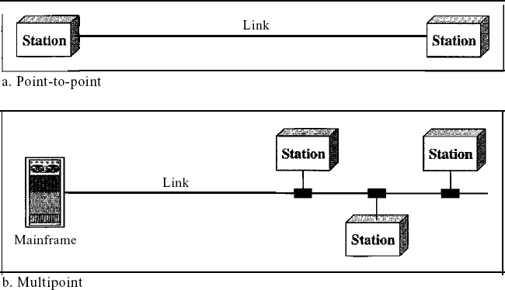

      - PhysicalTopology
The term physical topology refers to the way in which a network is laid out physically. One or more devices connect to a link; two or more links form a topology. The topology of a network is thegeometricrepresentationoftherelationshipofallthelinksandlinkingdevices(usually called nodes) to one another. There are four basic topologies possible: mesh, star, bus, and ring

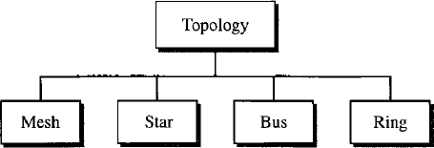

Mesh:Inameshtopology,everydevicehasadedicatedpoint-to-pointlinktoeveryother device. The term dedicated means that the link carries traffic only between the two devices it connects. To find the number of physical links in a fully connected meshnetwork with n nodes,wefirstconsiderthateachnodemustbeconnected toevery other node.Node 1mustbe connected to n - I nodes, node 2 must be connected to n – 1 nodes, and finally node n must be connected to n - 1 nodes. We need n(n - 1) physical links. However, if each physical link allows communicationinbothdirections(duplexmode),wecandividethenumberoflinksby 2.In other words, we can say that in a mesh topology, we need n(n -1) /2 duplex-mode links.
Toaccommodatethatmanylinks,everydeviceonthenetworkmusthaven–1input/output
(VO)portstobeconnectedtothe othern-1stations.
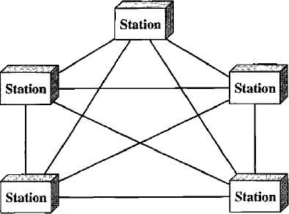

Advantages:
        - The use of dedicated links guarantees that each connection can carry its own data load,thuseliminatingthetrafficproblemsthatcanoccurwhenlinksmustbesharedby multiple devices.
        - Amesh topology isrobust.If one link becomesunusable, it doesnotincapacitate the entire system. Third, there is the advantage of privacy or security. When every message travels along a dedicated line, only the intended recipient sees it. Physical boundaries prevent other users from gaining access to messages. Finally, point-to-point links make fault identification and fault isolation easy. Traffic can be routed to avoid links with suspected problems. This facility enables the network manager to discover the precise location of the fault and aids in finding its cause and solution.
Disadvantages:
- Disadvantageofamesharerelatedtotheamountof cabling becauseevery devicemust be connected to every other device, installation and reconnection are difficult.
- Second, the sheer bulk of the wiring can be greater than the available space (in walls, ceilings, or floors) can accommodate. Finally, the hardware required to connect each link (I/O ports and cable) can be prohibitively expensive.
For these reasons a mesh topology is usually implemented in a limited fashion, for example, as a backbone connecting the main computers of a hybrid network that can include several other topologies.

StarTopology:
In a star topology, each device has a dedicated point-to-point link only to a central controller, usually called a hub. The devices are not directly linked to one another. Unlike a mesh topology, a star topology does not allow direct traffic between devices. The controller acts as an exchange: If one device wants to send data to another, it sends the data to the controller, whichthen relays the data to the other connected device .
A star topology is less expensive than a mesh topology. In a star, each device needs only one link and oneI/Oport toconnect ittoany number ofothers.Thisfactoralsomakesiteasy toinstall and reconfigure. Far less cabling needs to be housed, and additions, moves, and deletions involve only one connection: between that device and the hub.

Other advantages include robustness. If one link fails, only that link is affected. All other links remain active. Thisfactor also lends itself to easy fault identification and fault isolation. As longas the hub is working, it can be used to monitor link problems and bypass defective links.

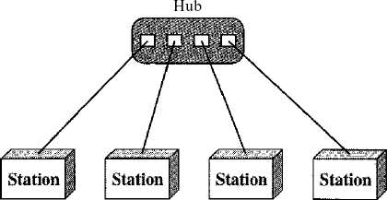

One big disadvantage of a star topology is the dependency of the whole topology on one single point, the hub. If the hub goes down, the whole system is dead. Although a star requires far less cable than amesh, eachnode must be linked to acentral hub.For thisreason, often more cabling is required in a star than in some other topologies (such as ring or bus).

BusTopology:
The preceding examples all describe point-to-point connections. A bus topology, on the other hand, is multipoint. One long cable acts as a backbone to link all the devices in a network
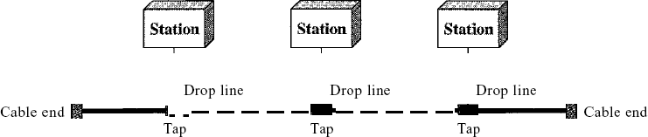
Nodes are connected to the bus cable by drop lines and taps. A drop line is a connection running between the device and the main cable. A tap is a connector that either splices into the main cable or punctures the sheathing of a cable to create a contact with the metallic core. As a signal travels along the backbone, some of its energy is transformed into heat. Therefore, it becomes weaker and weaker as it travels farther and farther. For this reason there is a limit on the number of taps a bus can support and on the distance between those taps.

Advantages of a bus topology include ease of installation. Backbone cable can be laid along the most efficient path, then connected to the nodes by drop lines of variouslengths.In thisway, abus uses less cabling than mesh or star topologies. In a star, for example, four network devices in the same room require four lengths of cable reaching all the way to the hub. In a bus, this redundancyiseliminated.Only thebackbonecablestretchesthroughtheentirefacility.Each drop line has to reach only as far as the nearest point on the backbone.
Disadvantages include difficult reconnection and fault isolation. A bus is usually designed to be optimally efficientatinstallation.Itcanthereforebedifficulttoaddnewdevices.Signal reflection at the taps can cause degradation in quality. This degradation can be controlled by limiting the number and spacing of devices connected to a given length of cable. Adding new devices may therefore require modification or replacement of the backbone.
In addition, a fault or break in the bus cable stops all transmission, even between devices on the same side of the problem. The damaged area reflects signals back in the direction of origin, creating noise in both directions.
Bus topology was the one of the first topologies used in the design of early local area networks. Ethernet LANs can use a bus topology, but they are less popular.
Ring Topology In a ring topology, each device has a dedicated point-to-point connection with onlythe two devices on either side of it. A signal is passed along the ring in one direction, from device to device, until it reaches its destination. Each device in the ring incorporates a repeater. When a device receives a signal intended for another device, its repeater regenerates the bits and passes them along
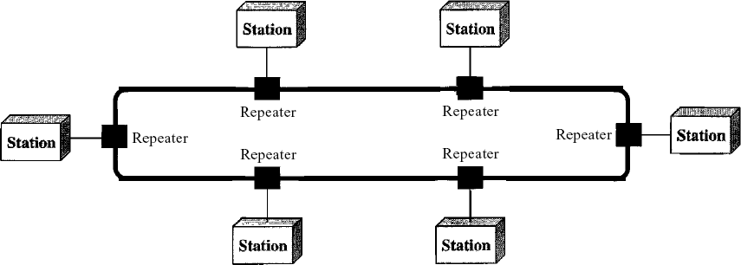

A ring is relatively easy to install and reconfigure. Each device is linked to only its immediate neighbors (either physically or logically). To add or delete a device requires changing only two connections. The onlyconstraints are media and traffic considerations (maximum ring length and number of devices). In addition, fault isolation is simplified. Generally in a ring, a signal is circulating at all times. If one device does not receive a signal within a specified period, it canissue an alarm. The alarm alerts the network operator to the problem and its location.
However, unidirectional traffic can be a disadvantage. In a simple ring, a break in the ring (such asa disabled station) can disable the entire network. Thisweaknesscanbe solved byusinga dual ring or a switch capable of closing off the break. Ring topology was prevalent when IBM introduced its local-area network Token Ring. Today, the need for higher-speed LANs has made this topologyless popular. Hybrid Topology A network can be hybrid. For example, we can havea main star topology with each branch connecting several stations in a bus topology as shown in Figure
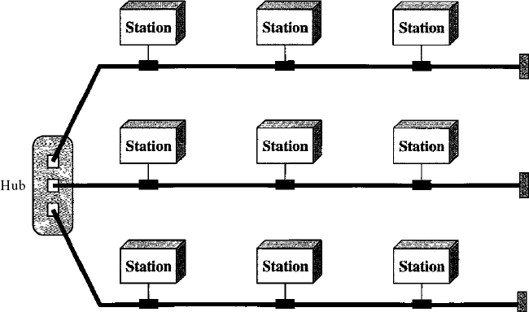

Categoriesof Networks

LocalAreaNetworks:
Local area networks, generally called LANs, are privately-owned networks within a singlebuilding or campus of up to a few kilometres in size. They are widely used to connect personal computers and workstations in company officesand factories toshare resources(e.g., printers) and exchange information. LANs are distinguished from other kinds of networks by three characteristics:
- Theirsize,
- Theirtransmissiontechnology,and
- Theirtopology.
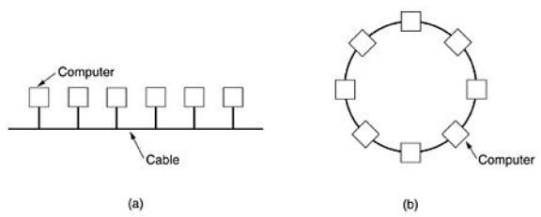
LANs are restricted in size, which means that the worst-case transmission time is bounded and known in advance. Knowing this bound makes it possible to use certain kinds of designs that would not otherwise be possible. It also simplifies network management. LANs may use a transmission technology consisting of a cable to which all the machines are attached, like the telephone company party lines once used in rural areas. Traditional LANs run at speeds of 10 Mbps to 100 Mbps, have low delay (microseconds or nanoseconds), and make very few errors. Newer LANs operate at up to 10 Gbps Various topologies are possible for broadcast LANs. Figure1 shows two of them. In a bus (i.e., a linear cable) network, at any instant at most one machine is the master and is allowed to transmit. All other machines are required to refrain from sending. An arbitration mechanism is needed to resolve conflicts when two or more machineswant to transmit simultaneously. The arbitration mechanism may be centralized or distributed. IEEE 802.3, popularly called Ethernet, for example, is a bus-based broadcast network with decentralized control, usually operating at 10 Mbps to 10 Gbps. Computers on an Ethernet can transmitwhenever they wantto;if two ormorepacketscollide, eachcomputer justwaitsa random time and tries again later.

Fig.1:Twobroadcastnetworks.(a)Bus.(b)Ring.

A second type of broadcastsystem isthe ring.Ina ring,each bitpropagates around onits own, not waiting for the rest of the packet to which it belongs. Typically, each bit circumnavigates the entire ring in the time it takes to transmit a few bits, often before the complete packet has even been transmitted. As with all other broadcast systems, some rule is needed for arbitrating simultaneousaccessestothering.Variousmethods,suchashaving themachinestaketurns,are in use. IEEE 802.5 (the IBM token ring), is a ring-based LAN operating at 4 and 16 Mbps. FDDIis another example of a ring network.

Metropolitan AreaNetwork(MAN):
MetropolitanAreaNetwork:
A metropolitan area network, or MAN, covers a city. The best-known example of a MAN is the cable television network available in many cities. This system grew from earlier community antenna systemsusedinareaswithpoorover-the-airtelevisionreception.Intheseearly systems, a large antenna was placed on top of a nearby hill and signal was then piped to the subscribers' houses.Atfirst,thesewere locally-designed,adhocsystems.Thencompaniesbeganjumping into the business, getting contracts from city governments to wire up an entire city. The next step was television programming and even entire channels designed for cable only. Often these channels were highly specialized, such as all news, all sports, all cooking, allgardening,and soon. But from their inception until the late 1990s, they were intended for television reception only. To a first approximation, a MAN might look something like the system shown inFig. In thisfigure both television signals and Internet are fed into the centralized head end for subsequent distribution to people's homes. Cable television is not the only MAN. Recent developments in high-speed wireless Internet access resulted in another MAN, which has been standardized asIEEE 802.16.
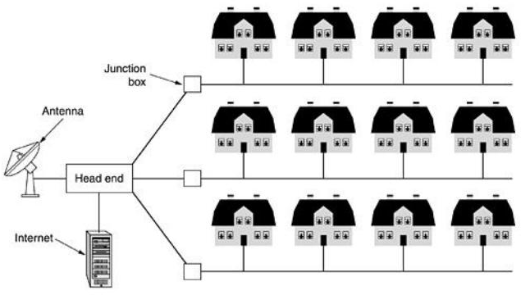

Fig.2:MetropolitanareanetworkbasedoncableTV.

A MAN is implemented by a standard called DQDB (Distributed Queue Dual Bus) or IEEE 802.16. DQDB has two unidirectional buses (or cables) to which all the computers are attached.

WideAreaNetwork(WAN). Wide Area Network:
A wide area network, or WAN, spans a large geographical area, often a country or continent. It contains a collection of machines intended for running user (i.e., application) programs. These machines are called as hosts. The hosts are connected by a communication subnet, or just subnet for short. The hosts are owned by the customers (e.g., people's personal computers), whereas the communication subnet is typically owned and operated by a telephonecompany orInternet service provider.Thejobofthesubnetistocarry messagesfromhosttohost, justasthe telephone system carries words from speaker to listener.
Separationofthe purecommunication aspectsofthe network(the subnet)fromtheapplication aspects (the hosts), greatly simplifies the complete network design. In most wide area networks, thesubnetconsistsoftwodistinctcomponents:transmissionlinesandswitchingelements.Transmission lines move bits between machines. They can be made of copper wire, optical fiber, or even radio links. In most WANs, the network contains numerous transmission lines, each one connectingapairofrouters.Iftworoutersthatdonotshareatransmissionlinewishto communicate,theymustdothisindirectly,viaotherrouters.Whenapacketissentfromone router to another via one or more intermediate routers, the packet is received at each intermediate routerinitsentirety,storedthereuntiltherequiredoutputlineisfree,andthenforwarded.A subnetorganizedaccordingtothisprincipleiscalledastore-and-forwardorpacket-switched subnet.Nearlyallwideareanetworks(exceptthoseusingsatellites)havestore-and-forward subnets. When the packets are small and all the same size, they are often called cells.
Theprincipleofapacket-switchedWANissoimportant.Generally,whenaprocessonsome host has a message to be sent to a process on some other host, the sending host first cuts the message into packets, each one bearing its number in the sequence. These packets aretheninjected into the network one at a time in quick succession. The packets are transported individually overthenetworkanddepositedatthereceiving host,wheretheyarereassembled into the original message and delivered to the receiving process. A stream of packets resultingfrom some initial message is illustrated in Fig.

In this figure, all the packets follow the route ACE, rather than ABDE or ACDE. Insomenetworks all packets from a given message must follow the same route; in others each packed is routed separately.Of course, ifACE is the bestroute, all packetsmay be sentalongit, even if each packet is individually routed.
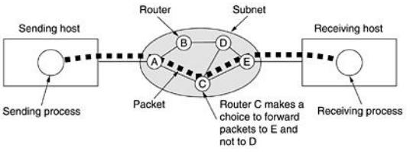

Fig.3.1:Astreamofpacketsfromsendertoreceiver.
Not all WANs are packet switched. A second possibility for a WAN is a satellite system. Each router has an antenna through which it can send and receive. All routers can hear the output from thesatellite,andinsomecasestheycanalsoheartheupwardtransmissionsoftheirfellow routers to the satellite as well. Sometimes the routers are connected to a substantial point-to-point subnet, with only some of them having a satellite antenna. Satellite networks are inherently broadcast and are most useful when the broadcast property is important.

THEINTERNET
The Internet has revolutionized many aspects of our daily lives. It has affected the way we do business as well as the way we spend our leisure time. Count the ways you've used the Internet recently. Perhaps you've sent electronic mail (e-mail) to a business associate, paid a utility bill,reada newspaperfroma distant city, orlookedupa localmovie schedule-all by using the Internet. Or maybe you researched a medical topic, booked a hotel reservation, chatted with a fellowTrekkie,orcomparison-shoppedforacar.TheInternetisacommunicationsystemthat has brought a wealth of information to our fingertips and organized it for our use.

ABriefHistory
A network is a group of connected communicating devices such as computers and printers. An internet (note the lowercase letter i) is two or more networks that can communicate with each other. The most notable internet is called the Internet (uppercase letter I), a collaboration of more than hundreds of thousands of interconnected networks. Private individuals as well as various organizationssuchasgovernmentagencies,schools,researchfacilities,corporations,and libraries in more than 100 countries use the Internet. Millions of people are users. Yet this extraordinary communication system only came into being in 1969.
In the mid-1960s, mainframe computers in research organizations were standalone devices. Computers from different manufacturers were unable to communicate with one another. The AdvancedResearchProjectsAgency(ARPA)intheDepartmentofDefense(DoD)was interested in finding a way to connect computers so that the researchers they funded could share their findings, thereby reducing costs and eliminating duplication of effort.
In 1967, at an Association for Computing Machinery (ACM) meeting, ARPA presented its ideas for ARPANET, a small network of connected computers. The idea was that each host computer (notnecessarilyfromthesamemanufacturer)wouldbeattachedtoaspecializedcomputer, called an inteiface message processor (IMP). The IMPs, in tum, would be connected to one another. Each IMP had to be able to communicate with other IMPs as well as with its ownattached host. By 1969, ARPANET was a reality. Four nodes, at the University of California atLos Angeles (UCLA), the University of California at Santa Barbara (UCSB), Stanford Research Institute (SRI), and the University of Utah, were connected via the IMPs to form a network. SoftwarecalledtheNetworkControlProtocol(NCP)providedcommunicationbetweenthe hosts.
In 1972, Vint Cerf and Bob Kahn, both of whom were part of the core ARPANET group, collaborated on what they called the Internetting Projec1. Cerf and Kahn's landmark 1973 paper outlined the protocols to achieve end-to-end delivery of packets. This paper on Transmission Control Protocol (TCP) included concepts such as encapsulation, the datagram, and the functions of a gateway. Shortly thereafter, authorities made a decision to split TCP into two protocols: Transmission Control Protocol (TCP) and Internetworking Protocol (lP). IP would handledatagramroutingwhileTCPwouldberesponsibleforhigher-levelfunctionssuchas

segmentation, reassembly,anderror detection. The internetworking protocolbecame known as TCPIIP.

TheInternetToday
The Internet has come a long way since the 1960s. The Internet todayis not a simple hierarchical structure. It is made up of many wide- and local-area networks joined by connecting devices and switchingstations.ItisdifficulttogiveanaccuraterepresentationoftheInternetbecauseitis continually changing-new networks are being added, existing networks are adding addresses, and networksofdefunctcompaniesarebeingremoved.TodaymostenduserswhowantInternet connectionusetheservicesofInternetservice providers(lSPs).There areinternationalservice providers, national service providers, regional service providers, and local service providers. The Internet today is run by private companies, not the government. Figure 1.13 shows a conceptual (not geographic) view of the Internet.
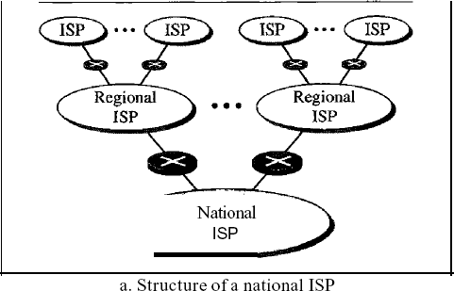
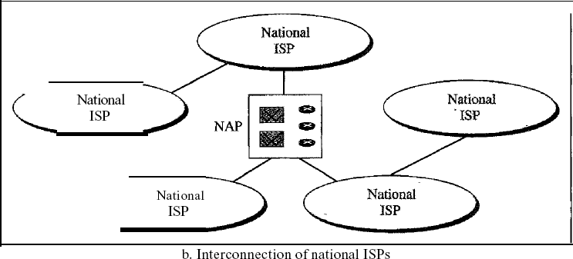

InternationalInternetService Providers:
At the top of the hierarchy are the international service providers that connect nations together.
NationalInternetServiceProviders:
The national Internet service providers are backbone networks created and maintained by specialized companies. There are many national ISPs operating in North America; some of the most well known are SprintLink, PSINet, UUNet Technology,AGIS, and internet Mel. Toprovide connectivity between the end users, these backbone networks are connected by complex switching stations (normally run by a third party) called network access points (NAPs). Some national ISP networks are also connected to one another by private switching stations called peering points. These normally operate at a high data rate (up to 600 Mbps).
RegionalInternetServiceProviders:
RegionalinternetserviceprovidersorregionalISPsare smallerISPsthatareconnected to one or more national ISPs. Theyare at the third level of the hierarchy with a smaller data rate. Local Internet Service Providers:
LocalInternetserviceprovidersprovidedirectservicetotheendusers.ThelocalISPs can beconnected to regionalISPsordirectly tonationalISPs.Most endusers are connected to the local ISPs. Note that in this sense, a local ISP can be a company that just provides Internet services, a corporation with a network that supplies services to its own employees, or a nonprofit organization,suchasacollegeorauniversity,thatrunsitsownnetwork.Eachofthese local ISPs can be connected to a regional or national service provider.

PROTOCOLSANDSTANDARDS

Protocols:
In computer networks, communication occurs between entities in different systems. An entity is anything capable of sending or receiving information. However, two entities cannot simply send bit streams to each other and expect to be understood. For communication to occur, the entities must agree on a protocol. Aprotocol is a set ofrules thatgovern data communications.Aprotocoldefineswhatiscommunicated,howitiscommunicated,andwhen it is communicated. The key elements of a protocol are syntax, semantics, and timing.

- Syntax. The term syntax refers to the structure or format of the data, meaning the orderinwhichthey arepresented.For example,asimpleprotocolmightexpectthefirst8bitsofdata to be the address of the sender, the second 8 bits to be the address of the receiver, and the rest of the stream to be the message itself.
- Semantics. The word semantics refers to the meaning of each section of bits. How is a particular patterntobeinterpreted,andwhatactionistobetakenbasedonthatinterpretation? For example,doesanaddressidentify theroute tobetakenorthefinaldestination ofthe message?
- Timing. The termtiming refersto two characteristics:when data shouldbe sentand howfast they can be sent. For example, if a sender produces data at 100Mbpsbutthe receiver can process data atonly 1Mbps,the transmissionwill overload thereceiverandsomedatawill be lost.

Standards
Standards are essential in creating and maintaining an open and competitive market for equipment manufacturers and in guaranteeing national and international interoperability of dataand telecommunications technology and processes. Standards provide guidelines tomanufacturers, vendors, government agencies, and other service providers to ensure the kind of interconnectivity necessary in today's marketplace and in international communications.
Data communication standards fall into two categories: de facto (meaning "by fact" or "by convention") and de jure (meaning "by law" or "by regulation").
- De facto. Standards that have not been approved by an organized body but have been adopted as standards through widespread use are de facto standards. De facto standards are often established originally by manufacturers who seek to define the functionality of a new product or technology.
- De jure. Those standards that have been legislated by an officially recognized body are de jure standards.

LAYEREDTASKS
We use the concept of layers in our daily life. As an example, let us consider two friends who communicate through postal maiL The process of sending a letter to a friend would be complex if there were no services available from the post office. Below Figure shows the steps in this task.
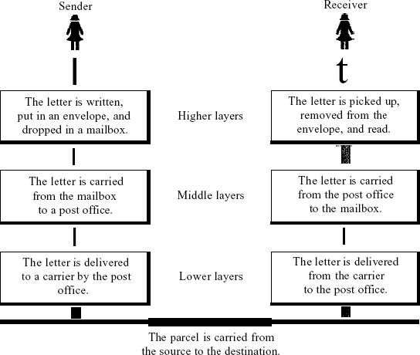
Sender,Receiver,andCarrier
In Figure we have a sender, a receiver, and a carrier that transports the letter. There is a hierarchy of tasks.
Atthe Sender Site
Letusfirstdescribe,in order,theactivitiesthattakeplaceatthe sendersite.
- Higherlayer.Thesenderwritestheletter,insertstheletterinanenvelope,writesthe sender and receiver addresses, and drops the letter in a mailbox.
- Middle layer.Theletterispickedupbyaletter carrieranddeliveredtothe postoffice.
- Lowerlayer.Theletteris sorted atthepostoffice;acarriertransportstheletter.
0n the Way: The letter is then on its way to the recipient. On the way to the recipient's local post office, the letter may actually go through a central office. In addition, it may be transported by truck, train, airplane, boat, or a combination of these.

Atthe ReceiverSite
- Lower layer.Thecarrier transportstheletter tothepostoffice.
- Middlelayer.The letterissortedanddelivered tothe recipient'smailbox.
- Higherlayer. Thereceiverpicksupthe letter,opensthe envelope,andreadsit.

TheOSIReferenceModel:
The OSI model (minus the physical medium) is shown in Fig. This model is based on a proposal developed by the International Standards Organization (ISO) as a first step toward international standardization of the protocols used in the various layers (Day and Zimmermann, 1983). It was revised in 1995(Day, 1995). The model is called the ISO-OSI (Open Systems Interconnection) Reference Model because it deals with connecting opensystems—that is, systems that are openfor communication with other systems.
TheOSImodelhassevenlayers.Theprinciplesthatwere appliedtoarrive atthesevenlayers can be briefly summarized as follows:
1.Alayershould becreatedwhereadifferentabstraction is needed.
- Eachlayershouldperformawell-definedfunction.
- The function of each layer should be chosen with an eye toward defining internationally standardized protocols.
- Thelayerboundariesshouldbechosentominimizetheinformationflowacrosstheinterfaces.
- The number of layers should be large enough that distinct functions need not be throwntogether inthe samelayeroutofnecessity and smallenough thatthearchitecture doesnot become unwieldy.

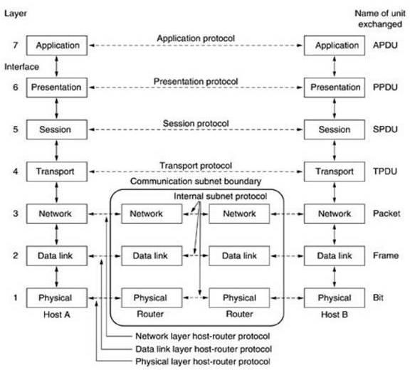.

Fig.4: TheOSIreference model
ThePhysicalLayer:
The physical layer is concerned with transmitting raw bits over a communication channel. The design issues have to do with making sure that when one side sends a 1 bit, it is received by the other side as a 1 bit, not as a 0 bit.

TheData LinkLayer:
The main task of the data link layer is to transform a raw transmission facility into a line that appears free of undetected transmission errors to the network layer. It accomplishes this task by having the sender break up the input data into data frames (typically a few hundred or a few thousand bytes) and transmits the frames sequentially. If the service is reliable, the receiver confirms correct receipt of each frame by sending back an acknowledgement frame.
Another issue that arises in the data link layer (and most of the higher layers as well)is how to keep a fast transmitter from drowning a slow receiver in data. Some traffic regulation mechanismisoftenneededtoletthetransmitterknowhowmuchbufferspacethereceiverhasatthe moment. Frequently, this flow regulation and the error handling are integrated.

TheNetwork Layer:
The network layer controls the operation of the subnet. A key design issue is determining how packets are routed from source to destination. Routes can be based on static tables that are ''wired into'' the network and rarely changed. They can also be determined at the start of each conversation,forexample,aterminalsession(e.g.,alogintoaremotemachine).Finally,they can be highly dynamic,being determined anewfor each packet, toreflect the current network load.
If too many packets are present in the subnet at the same time, they will get in one another's way, forming bottlenecks. The control of such congestion also belongs to the network layer. More generally, the quality of service provided (delay, transit time, jitter, etc.) is also a network layer issue.
When a packet has to travel from one network to another to get to its destination, many problems can arise. The addressing used by the second network may be different from the first one. The second one may notaccept the packet at all because it is too large. The protocols may differ, andso on. It is up to the network layer to overcome all these problems to allow heterogeneousnetworks to be interconnected. In broadcast networks, the routing problem is simple, so the network layer is often thin or even nonexistent.

TheTransportLayer:
Thebasicfunctionofthetransportlayeristoacceptdatafromabove,splititupintosmaller units if need be, pass these to the network layer, and ensure that the pieces all arrive correctly atthe other end. Furthermore, all this must be done efficiently and in a way that isolates the upper layersfrom the inevitable changes in thehardware technology.Thetransportlayer also determineswhattypeofservicetoprovidetothesessionlayer,and,ultimately,totheusersof thenetwork.Themostpopulartypeoftransportconnectionisanerror-freepoint-to-point channel that delivers messages or bytes in the order in which they were sent. However, other possible kinds of transport service are the transporting of isolated messages, with no guarantee abouttheorderofdelivery,andthebroadcastingofmessagestomultipledestinations.Thetype of service is determined when the connection is established.
The transport layer is a true end-to-end layer, all the way from the source to the destination. In otherwords,a programon the source machine carriesona conversationwithasimilarprogram on the destination machine, using the message headers and control messages.In the lower layers,

the protocols are between each machine and its immediate neighbours, and not between the ultimate source and destination machines, which may be separated by many routers.

The Session Layer:
Thesessionlayerallowsusersondifferentmachinestoestablishsessionsbetweenthem. Sessions offer various services, including dialog control (keeping track of whose turn it is to transmit), token management (preventing two parties from attempting the same criticaloperationat the same time), and synchronization (check pointing long transmissions to allow them to continue from where they were after a crash).

ThePresentationLayer:
The presentation layer is concerned with the syntax and semantics of the information transmitted. Inordertomakeitpossibleforcomputerswithdifferentdatarepresentationstocommunicate, the data structures to be exchanged can be defined in an abstract way, along with a standard encoding to be used ''on the wire.'' The presentation layer manages these abstract data structures and allows higher-level data structures (e.g., banking records), to be defined and exchanged.

TheApplicationLayer:
The application layer contains a variety of protocols that are commonly needed by users. One widely-used application protocolisHTTP (HypertextTransferProtocol),which isthe basis for the World Wide Web. When a browser wants a Web page, it sends the name ofthe page itwantsto the server using HTTP. The server then sends the page back. Other application protocols are used for file transfer, electronic mail, and network news.

TheTCP/IP ReferenceModel:
The TCP/IP reference model was developed prior to OSI model. The major designgoalsof thismodel were,
- Toconnectmultiplenetworkstogether sothattheyappearasasinglenetwork.
- Tosurvive afterpartialsubnethardwarefailures.
- Toprovideaflexiblearchitecture.
UnlikeOSI referencemodel,TCP/IPreferencemodelhasonly4layers.Theyare,
- Host-to-NetworkLayer
- Internet Layer

- TransportLayer
- ApplicationLayer Application Layer Transport Layer Internet Layer
Host-to-NetworkLayer

Host-to-NetworkLayer:
The TCP/IP reference model does not really say much about what happens here, except to pointout that the host has to connect to the network using some protocol so it can send IP packets to it. This protocol is not defined and varies from host to host and network to network.

InternetLayer:
This layer, called the internet layer, is the linchpin that holds the whole architecture together. Its job is to permit hosts to inject packets into anynetwork and have theytravel independentlyto the destination (potentially on a different network). They may even arrive ina different order thanthey weresent,inwhichcaseitisthejobofhigherlayerstorearrangethem,ifin-orderdelivery is desired. Note that ''internet'' is used here in a generic sense, even though this layer is present in the Internet.
TheinternetlayerdefinesanofficialpacketformatandprotocolcalledIP(InternetProtocol). ThejoboftheinternetlayeristodeliverIPpacketswherethey aresupposedtogo.Packet routing isclearly the major issue here, as isavoiding congestion. For these reasons, itis reasonable to say that the TCP/IP internet layer is similar in functionality to theOSI networklayer. Fig. shows this correspondence.

TheTransportLayer:
ThelayerabovetheinternetlayerintheTCP/IPmodelisnowusually calledthetransportlayer. Itisdesignedtoallowpeerentitiesonthesourceanddestinationhoststocarryona conversation, just as in the OSI transport layer. Two end-to-end transport protocols have been defined here. The first one, TCP (Transmission Control Protocol), is a reliable connection-oriented protocol that allows a byte stream originating on one machine to be delivered without error on any other machine in the internet. It fragments the incoming byte stream into discrete messages and passes each one on to the internet layer. At the destination, the receiving TCP process reassembles the received messages into the output stream. TCP also handles flow control

tomakesureafastsendercannotswampaslowreceiverwithmoremessagesthanitcanhandle.
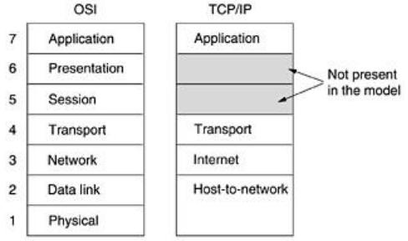

Fig.1:TheTCP/IP referencemodel.
Thesecondprotocolinthislayer,UDP(UserDatagramProtocol),isanunreliable, connectionless protocol for applications that do not want TCP's sequencing or flow control and wish to provide their own. It is also widely used for one-shot, client-server-type request-reply queries and applications in which prompt delivery is more important than accurate delivery, suchas transmitting speech or video. The relation of IP, TCP, and UDP is shown in Fig.2. Since the model was developed, IP has been implemented on many other networks.
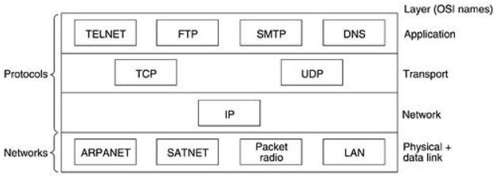

Fig.2:ProtocolsandnetworksintheTCP/IPmodelinitially.

TheApplicationLayer:
The TCP/IP modeldoes nothave session or presentation layers.On top of the transportlayer is the application layer. It contains all the higher-level protocols. The early ones included virtual terminal (TELNET), file transfer (FTP), and electronic mail (SMTP), as shown in Fig.6.2. The virtual terminal protocol allows a user on one machine to log onto a distant machine and work there. The file transfer protocol provides a way to move data efficiently from one machine to another. Electronic mail was originally just a kind of file transfer, but later a specialized protocol (SMTP) was developed for it. Many other protocols have been added to these over the years: the Domain Name System (DNS) for mapping host names onto their network addresses, NNTP, the protocolformovingUSENETnewsarticlesaround,andHTTP,theprotocolforfetchingpages on the World Wide Web, and many others.

Comparisonofthe OSI andTCP/IPReferenceModels:
The OSI and TCP/IP reference models have much in common. Both are based on the concept of a stack of independent protocols. Also, the functionality ofthe layers is roughlysimilar. For example, in both models the layers up through and including the transport layer are there to provide an end-to-end, network-independent transport service to processes wishing to communicate. These layers form the transport provider. Again in both models, the layers above transport are application-oriented users of the transport service. Despite these fundamental similarities, the two models also have many differences Three concepts are central to the OSI model:
- Services.
- Interfaces.
- Protocols.
Probablythe biggest contribution of the OSI model is to make the distinction between these three conceptsexplicit.Eachlayerperformssomeservicesforthelayeraboveit.Theservice definition tells what the layer does, not how entities above it access it or how the layer works. It defines the layer's semantics.
A layer's interface tells the processes above it how to access it.It specifies what theparametersare and what results to expect. It, too, says nothing about how the layer works inside.

Finally, the peer protocols used in a layer are the layer's own business. It can use any protocols it wants to, as long as it gets the job done (i.e., provides the offered services). It canalso change them at will without affecting software in higher layers.
The TCP/IP model did not originally clearly distinguish between service, interface, and protocol, although people have tried to retrofit it after the fact to make it more OSI-like. For example, the only real services offered by the internet layer are SEND IP PACKET and RECEIVE IPPACKET.
Asaconsequence,theprotocolsintheOSImodelarebetterhiddenthanintheTCP/IPmodel andcanbereplacedrelativelyeasilyasthetechnologychanges.Beingabletomakesuch changes is one of the main purposes of having layered protocols in the first place. The OSI reference model was devised before the corresponding protocols were invented. This ordering means that the model was not biased toward one particular set of protocols, a fact that made it quite general. The downside of this ordering is that the designers did not have much experience with the subject and did not have a good idea of which functionality to put in which layer.
Another difference is in the area of connectionless versus connection-oriented communication.The OSI model supports both connectionless and connection-oriented communication in the network layer,butonly connection-orientedcommunicationinthetransportlayer,whereit counts (because the transport service is visible to the users). The TCP/IP model has only onemode in the network layer (connectionless) but supports both modes in the transport layer, giving the users a choice. This choice is especially important for simple request-response protocols.

UNIT-2

PhysicalLayerandOverviewofPLSwitching

MULTIPLEXING
Multiplexingisthesetoftechniquesthatallowsthesimultaneoustransmissionofmultiple signals across a single data link.
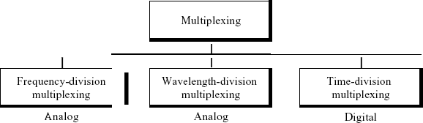

FigureCategories ofmultiplexing

Frequency-DivisionMultiplexing
Frequency-division multiplexing (FDM) is an analog technique that can be applied when the bandwidth of a link (in hertz) is greater than the combined bandwidths of the signals to be transmitted. In FOM, signals generated by each sending device modulate different carrier frequencies. Thesemodulated signalsare thencombined into a singlecomposite signalthatcan be transported by the link. Carrier frequencies are separated by sufficient bandwidth to accommodate the modulated signal. These bandwidth ranges are the channels through which the various signals travel. Channels can be separated by strips of unused bandwidth-guard bands-to prevent signals from overlapping. In addition, carrier frequencies must not interfere with the original data frequencies.
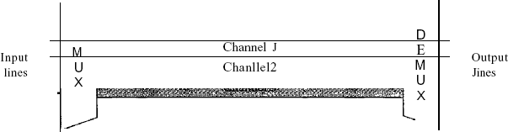
Figure 1gives aconceptualview ofFDM.In this illustration, the transmission path is divided into three parts, each representing a channel that carries one transmission.

Fig:FDM

WeconsiderFDMtobeananalogmultiplexing technique;however,thisdoesnotmeanthat FDMcannotbeusedtocombinesourcessendingdigitalsignals.Adigitalsignalcanbe converted to an analog signal before FDM is used to multiplex them.
Multiplexing Process
Figure 2 is a conceptual illustration of the multiplexing process. Each source generates a signal of a similar frequency range. Inside the multiplexer, these similar signals modulates different carrier frequencies (/1,12, and h). The resulting modulated signals are then combinedinto a single composite signal that is sent out over a media link that has enough bandwidth to accommodate it.
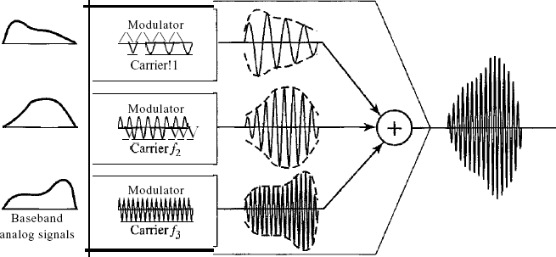

Figure2FDMprocess
Demultiplexing Process
The demultiplexer uses a series of filters to decompose the multiplexed signal into its constituent component signals. The individual signals are then passed to a demodulator that separates them from their carriers and passes them to the output lines. Figure 3 is a conceptual illustration of demultiplexing process.
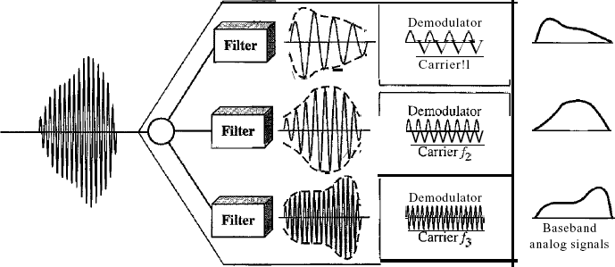

Figure3FDM de-multiplexingexample

Wavelength-DivisionMultiplexing
Wavelength-division multiplexing (WDM) is designed to use the high-data-rate capability offiber-optic cable. The optical fiber data rate is higher than the data rate of metallic transmission cable. Using a fiber-optic cable for one single line wastes the available bandwidth. Multiplexing allows us to combine several lines into one.
WDMisconceptuallythesameasFDM,exceptthatthemultiplexinganddemultiplexing involve optical signals transmitted through fiber-optic channels. The idea is the same: We are combining different signals of differentfrequencies.The difference isthatthe frequenciesare very high.
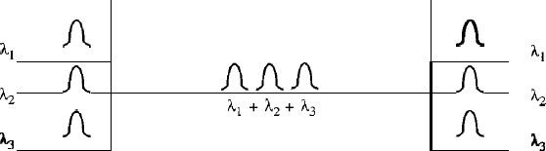
Figure4givesaconceptualview ofaWDMmultiplexer anddemultiplexer.Very narrowbands of light from different sources are combined to make a wider band of light. At the receiver, the signals are separated by the demultiplexer.
Figure4Wavelength-divisionmultiplexing
Although WDM technology is very complex, the basic idea is very simple. We want to combine multiple light sources into one single light at the multiplexer and do the reverse at the demultiplexer. The combining and splitting of light sources are easily handled by a prism. Recall from basic physics that a prism bends a beam of light based on the angle of incidence and the frequency. Using this technique, a multiplexer can be made to combine several input beams of light, each containing a narrow band of frequencies, into one output beam of a wider band of frequencies.Ademultiplexercanalsobemadetoreversetheprocess.Figure5showsthe concept.
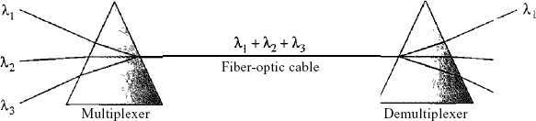

Figure5Prismsinwavelength-divisionmultiplexinganddemultiplexing

SynchronousTime-DivisionMultiplexing
Time-divisionmultiplexing (TDM)isa digitalprocessthatallowsseveralconnectionstoshare the high bandwidth of a linle Instead of sharing a portion of the bandwidth as in FDM, time is shared.Eachconnection occupies a portion oftime in the link. Figure 6gives a conceptual viewof TDM.Notethatthesamelink isusedasinFDM;here,however,thelink isshownsectioned by time rather than by frequency. In the figure, portions of signals 1,2,3, and 4 occupy the link sequentially.
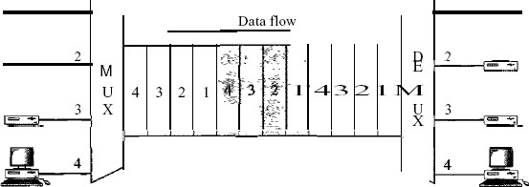

Figure6TDM
Note that in Figure 6 we are concerned with only multiplexing, not switching. This means that all the data in a message from source 1 always go to one specific destination, be it 1, 2, 3, or 4. The delivery is fixed and unvarying, unlike switching. We also need to remember thatTDM is, in principle, a digital multiplexing technique. Digital data from different sources are combined into one timeshared link. However, this does not mean that the sources cannot produce analog data; analog data can be sampled, changed to digital data, and then multiplexed by using TDM.
Wecandivide TDMintotwodifferentschemes:synchronousandstatistical.
In synchronous TDM, each input connection has an allotment in the output even if it isnot sending data.
TimeSlotsandFrames
In synchronous TDM, the data flow of each input connection is divided into units, where each input occupies one input time slot. A unit can be 1 bit, one character, or one block of data. Each inputunitbecomesoneoutputunitandoccupiesoneoutputtimeslot.However,thedurationof anoutputtimeslotisntimesshorterthanthe durationofaninputtimeslot.Ifaninputtimeslot isTs,theoutputtimeslotisTins,wherenisthenumberofconnections.Inotherwords,aunit

in the output connection has a shorter duration; it travels faster. Figure 7 shows an example of synchronous TDM where n is 3.

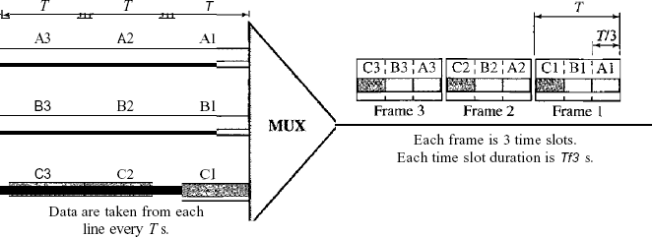
Figure7Synchronoustime-divisionmultiplexing
In synchronous TDM, a round of data units from each input connection is collected into a frame (we will see the reason for this shortly). If we have n connections, a frame is divided into n time slotsandoneslotisallocatedforeachunit,oneforeachinputline.If the durationofthe input unit isT, the durationofeachslot isTinand the duration of eachframe isT(unlessaframe carries some other information, as we will see shortly).
Thedatarateoftheoutputlinkmustbentimesthedatarateofaconnectiontoguaranteethe flowofdata.InFigure7,the datarateofthelinkis3timesthedatarateofaconnection; likewise, the duration of a unit on a connection is3 times thatofthe time slot (duration of a uniton thelink).Inthe figurewerepresentthedataprior tomultiplexing as3timesthe size ofthe data after multiplexing. This is just to convey the idea that each unit is 3 times longer in duration before multiplexing than after. Time slots are grouped into frames. A frame consists of one complete cycle of time slots, with one slot dedicated to each sending device. In a system with n input lines, each frame has n slots, with each slot allocated to carrying data from a specific input line.
Interleaving
TDM can be visualized as twofast-rotating switches, one on the multiplexing side andthe otheron the demultiplexing side. The switches are synchronized and rotate at the same speed, but in oppositedirections.Onthemultiplexingside,astheswitchopensinfrontofaconnection,that

connection has the opportunity tosend a unit onto the path. This processis calledinterleaving. On the demultiplexing side, as the switch opens in front of a connection, that connection has the opportunity to receive a unit from the path.
Figure8showsthe interleavingprocessfortheconnectionshowninFigure7.
In this figure, we assume that no switching is involved and that the data from the firstconnection at the multiplexer site go to the first connection at the demultiplexer
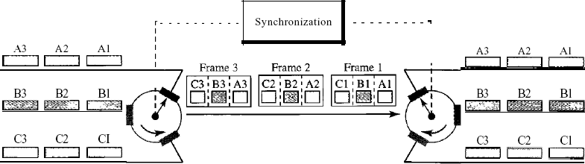

Figure8Interleaving
Empty Slots
Data RateManagement

MultilevelMultiplexing
- Multiple-SlotAllocation
- PulseStuffing Frame Synchronizing DigitalSignalService

StatisticalTime-Division Multiplexing
Addressing
Figure a also shows a major difference between slots in synchronous TDM and statistical TDM.AnoutputslotinsynchronousTDMistotally occupiedby data;instatisticalTDM,aslotneeds to carry data as well as the address of the destination.
In synchronous TDM, there is no need for addressing; synchronization and preassigned relationships between the inputs and outputs serve as an address. We know, for example,thatinput 1 always goes to input 2. If the multiplexer and the demultiplexer are synchronized, this is guaranteed. In statistical multiplexing, there is no fixed relationship between the inputs andoutputs because there are no preassigned orreservedslots.We need to include the addressof the

34

receiver inside each slot to show where it is to be delivered. The addressing in its simplest formcan be n bits to define N different output lines with n =10g2 N. For example, for eight different output lines, we need a 3-bit address.
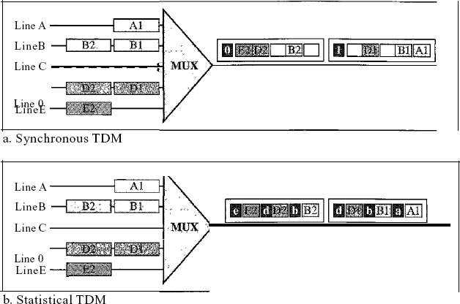

FigureaTDMslotcomparison
SlotSize
Since a slotcarries bothdata and anaddress in statistical TDM,the ratio of the data sizeto address size must be reasonable to make transmission efficient. For example, it would be inefficient to send 1 bit per slot asdata when the address is 3 bits. Thiswouldmean an overheadof 300percent.InstatisticalTDM,ablock ofdataisusually many byteswhile theaddressisjust a few bytes.
NoSynchronizationBit
There is another difference between synchronous and statistical TDM, but this time it is at the frame level. The frames in statistical TDM need not be synchronized, so we do not need synchronization bits.
Bandwidth
In statistical TDM, the capacity of the link is normally less than the sum of the capacities of each channel. The designers of statistical TDM define the capacityof the link based on the statistics of the load for each channel. If on average only x percent of the input slots are filled, the capacity of the link reflects this. Of course, during peak times, some slots need to wait.

Switching
Anetwork isasetofconnecteddevices.Wheneverwehavemultipledevices,wehave theproblemofhowtoconnectthemtomakeone-to-onecommunicationpossible.Onesolution istomake a point-to-pointconnectionbetweeneachpair ofdevices(ameshtopology)or between a central device and every other device (a star topology). These methods, however, are impracticalandwastefulwhen appliedtovery largenetworks.Thenumberand lengthofthe linksrequiretoomuchinfrastructuretobecost-efficient,andthemajorityofthoselinkswould be idle most of the time. Other topologies employing multipoint connections, such as a bus, are ruled out because the distances between devices and the total number of devices increase beyond the capacities of the media and equipment.
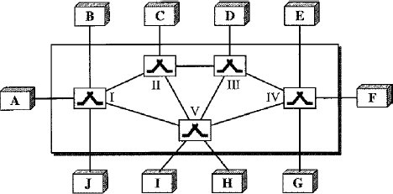
A better solution is switching. A switched network consists of a series of interlinkednodes, called switches. Switches are devices capable of creating temporary connections between two or more devices linked to the switch. In a switched network, some of these nodes are connected to the end systems (computers or telephones, for example). Others are used only for routing. Figure shows a switched network.

Theendsystems(communicatingdevices)arelabeledA,B,C,D,andsoon,andtheswitches are labeled I, II, III, IV, and V. Each switch is connected to multiple links.

Taxonomyofswitchednetworks
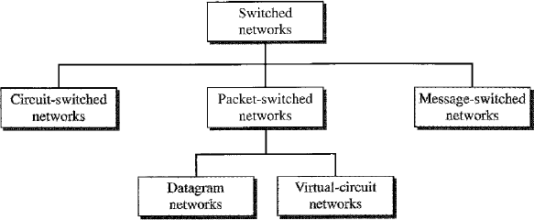

CIRCUIT-SWITCHEDNETWORKS
A circuit-switched network consists of a set of switches connected by physical links. A connection between two stations is a dedicated path made of one or more links. However, each connection uses only one dedicated channel on each link. Each link is normally divided into n channels by using FDM or TDM
Figure shows a trivial circuit-switched network with four switches and four links. Each link is divided into n (n is 3 in the figure) channels by using FDM or TDM.
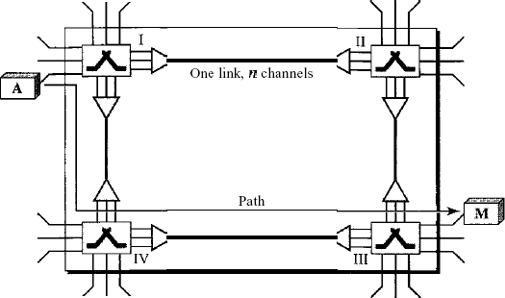

Fig: Atrivialcircuit-switchednetwork

Three Phases
The actual communication in a circuit-switched network requires three phases: connection setup, data transfer, and connection teardown.

SetupPhase:
Before the two parties (or multiple parties in a conference call) can communicate, a dedicated circuit (combination of channels in links) needs to be established. The end systems are normally connected through dedicated lines to the switches, so connection setup means creating dedicated channels between the switches. For example, in Figure,when system A needs toconnect to system M, it sends a setup request that includes the address of system M, to switch I. Switch I finds a channel between itself and switch IV that can be dedicated for this purpose.Switch I then sends the request to switch IV, which finds a dedicated channel between itself and switch III. Switch III informs system M of system A's intention at this time.
In the next step to making a connection, an acknowledgment from system M needs to be sent in the opposite direction to system A. Only after system A receives this acknowledgment is the connection established. Note that end-to-end addressing is required for creating a connection betweenthetwoendsystems.Thesecanbe,forexample,theaddressesofthecomputers assigned by the administrator in a TDM network, or telephone numbers in an FDM network.

Data Transfer Phase:
Aftertheestablishmentofthededicatedcircuit(channels),thetwopartiescantransfer
data.

TeardownPhase:
Whenoneofthepartiesneedstodisconnect,asignalissenttoeachswitchtoreleasethe resources.
Efficiency:
It can be argued that circuit-switched networks are not as efficient as the other two typesof networks because resources are allocated during the entire duration of the connection. These resourcesareunavailabletootherconnections.Inatelephonenetwork,peoplenormally terminate the communication when they have finished their conversation. However, in computer networks, a computer can be connected to another computer even if there is no activityfor a long time. In this case, allowing resources to be dedicated means that other connections are deprived.

Delay
Althoughacircuit-switchednetworknormallyhaslowefficiency,thedelayinthistype
of network is minimal. During data transfer the data are not delayed at each switch; the resources are allocated for the duration of the connection. Figure 8.6 shows the idea of delay in a circuit- switchednetwork whenonly twoswitches are involved.AsFigure shows, there is nowaiting time at each switch. The total delay is due to the time needed to create the connection, transfer data, and disconnect the circuit.
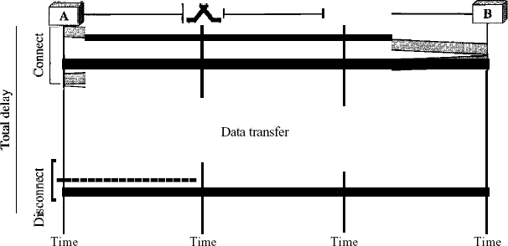

Fig:Delayinacircuit-switchednetwork
The delay caused by the setup is the sum of four parts: the propagation time of the sourcecomputer request (slope of the first gray box), the request signal transfer time (height of the first gray box), the propagation time of the acknowledgment from the destination computer (slope ofthe second gray box), and the signal transfer time of the acknowledgment (height of the second gray box). The delay duetodata transfer isthe sum of twoparts: the propagation time(slope of the colored box) and data transfer time (height of the colored box), which can be very long. The third box shows the time needed to tear down the circuit. We have shown the case in which the receiver requests disconnection, which creates the maximum delay.

DATAGRAMNETWORKS
Inadatagramnetwork,eachpacketistreatedindependently ofallothers.Evenifa packet is part of a multipacket transmission, the network treats it as though it existed alone. Packets in this approach are referred to as datagrams.
Datagramswitchingisnormallydoneatthenetworklayer.Webrieflydiscussdatagram networkshereasacomparisonwithcircuit-switchedandvirtual-circuitswitchednetworks Figureshowshowthedatagramapproachisusedtodeliverfour packetsfromstationAtostation
X.Theswitchesinadatagramnetworkaretraditionallyreferredtoasrouters.Thatiswhywe use a different symbol for the switches in the figure.
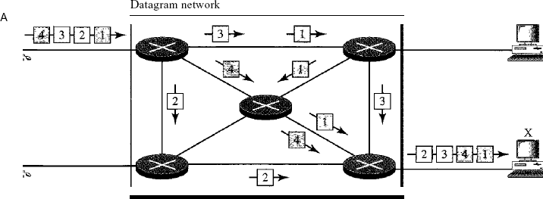
Fig:Adatagramnetworkwithfourswitches (routers)
In this example, all four packets (or datagrams) belong to the same message, but may travel different paths to reach their destination. This is so because the links may be involved in carrying packets from other sources and do not have the necessary bandwidth available to carry all the packets from A to X. This approach can cause the datagrams of a transmission to arrive at their destination out of order with different delays between the packets. Packets may also be lost or dropped because of a lack ofresources.Inmostprotocols, it is theresponsibility of anupper- layer protocol to reorder the datagrams or ask for lost datagrams before passing them on to the application.
The datagram networks are sometimes referred to as connectionless networks. The term connectionless here means that the switch (packet switch) does not keep information about the connection state. There are no setup or teardown phases. Each packet is treated the same by a switch regardless of its source or destination.

RoutingTable
If there are no setup or teardown phases, how are the packets routed to their destinations in a datagram network? In this type of network, each switch (or packet switch) has a routing table which is based on the destination address. The routing tables are dynamic and are updated periodically. The destination addresses and the corresponding forwarding output ports arerecordedinthetables.Thisisdifferentfromthetableofacircuitswitchednetworkinwhich each entry is created when the setup phase is completed and deleted when the teardown phase is over. Figure shows the routing table for a switch.
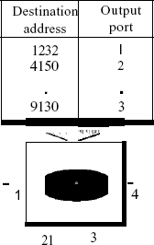

Fig:Routingtableinadatagramnetwork
Destination Address
Every packet in a datagram network carries a header that contains, among other information, the destination address of the packet. When the switch receives the packet, this destination address is examined; the routing table is consulted to find the corresponding port through which the packet should be forwarded. This address, unlike the address in a virtual- circuit-switched network, remains the same during the entire journey of the packet.

Efficiency
The efficiency of a datagram network is better than that of a circuit-switched network; resources are allocated only when there are packets to be transferred.Ifa sourcesendsa packet and thereisa delay of a few minutesbefore another packetcan be sent, theresourcescanbe reallocated during these minutes for other packets from other sources.

Delay
There may be greater delay in a datagram network than in a virtual-circuit network. Althoughtherearenosetupandteardownphases,eachpacketmay experienceawaitataswitchbeforeit is forwarded. In addition, since not all packets in a message necessarily travel through the same switches, the delay is not uniform for the packets of a message.
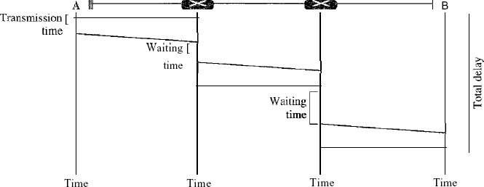

Fig:Delay inadatagram network
The packet travels through two switches. There are three transmission times (3T), three propagation delays (slopes 3't of the lines), and two waiting times (WI + w2)' We ignore the processing time in each switch. The total delay is
Totaldelay=3T +3t+WI+W2

VIRTUAL-CIRCUITNETWORKS:
A virtual-circuit network is a cross between a circuit-switched network and a datagram network. It has some characteristics of both.
- As in a circuit-switched network, there are setup and teardown phases in addition to the data transfer phase.
- Resources can be allocated during the setup phase, as in a circuit-switched network, or on demand, as in a datagram network.
- Asinadatagramnetwork,dataare packetizedandeachpacketcarriesanaddressinthe header. However, the address in the header has local jurisdiction (it defines what should be thenextswitchandthechannelonwhichthepacketisbeingcanied),notend-to-endjurisdiction. Thereadermay askhowtheintermediateswitchesknowwheretosendthepacketifthereisno

final destination address carried by a packet. The answer will be clear when we discuss virtual- circuit identifiers in the next section.
- As in a circuit-switched network, all packets follow the same path established during the connection.
- A virtual-circuit network is normally implemented in the data link layer, while a circuit- switched network is implemented in the physical layer and a datagram network in the network layer. But this may change in the future. Figure is an example of a virtual-circuit network. The network hasswitches thatallow traffic from sources to destinations. Asource or destination canbe a computer, packet switch, bridge, or any other device that connects other networks.
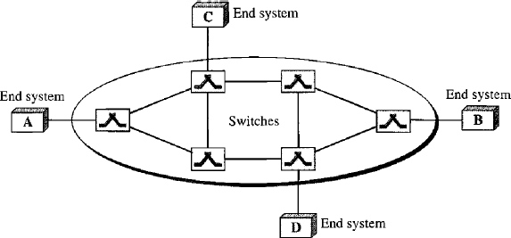
Figa:Virtual-circuitnetwork

Addressing
In a virtual-circuit network, two types of addressing are involved: global and local (virtual-circuit identifier).
Global Addressing: A source or a destination needs to have aglobal address-an address that canbe unique in the scope of the network or internationally if the network is part of an international network. However, we will see that a global address in virtual-circuit networks is used only to create a virtual-circuit identifier, as discussed next.
Virtual-CircuitIdentifier:Theidentifierthatisactuallyusedfordatatransferiscalledthe virtual-circuit identifier (Vel). A vel, unlike a global address, is a small number that has only switchscope;itisusedbyaframebetweentwoswitches.Whenaframearrivesataswitch,it has a VCI;when it leaves, ithas a different VCl. Figure 8.11 shows how theVCI in a dataframe

changesfromoneswitchtoanother.NotethataVCI doesnotneedtobealargenumbersince each switch can use its own unique set of VCls.
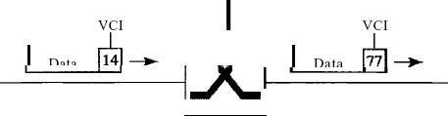

Figure1Virtual-circuitidentifier
ThreePhases
As in a circuit-switched network, a source and destination need to go through three phases in a virtual-circuit network: setup, data transfer, and teardown. In the setup phase, the source and destination use theirglobal addresses tohelpswitchesmaketableentriesfor the connection.In the teardown phase, the source and destination inform the switches to delete the corresponding entry. Data transfer occurs between these two phases. We first discuss the data transfer phase, which is more straightforward; we then talk about the setup and teardown phases.
Data TransferPhase
Totransferaframefromasourcetoitsdestination,allswitchesneedtohaveatableentryfor this virtual circuit. The table, in its simplest form, has four columns. This means that the switch holds four pieces of information for each virtual circuit that is already set up. We show later how the switches make their table entries, but for the moment we assume that each switch has a table with entries for all active virtual circuits.Figure 2 shows such a switchand its corresponding table. And also shows a frame arriving at port 1 with a VCI of 14. When the frame arrives, the switch looks in its table to find port 1 and a VCI of 14. When it is found, the switch knows to change the VCI to 22 and send out the frame from port 3.Figure 3 shows how a frame fromsource A reaches destination B and how its VCI changes during the trip. Each switch changes the VCI and routes the frame. The data transfer phase is active until the source sends all its frames to the destination. The procedure at the switch is the same for each frame of a message. The process creates a virtual circuit, not a real circuit, between the source and destination.
SetupPhase

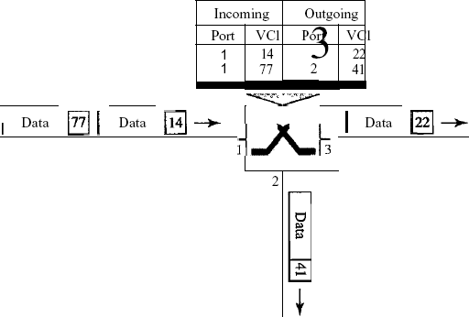
In the setup phase, a switch creates an entry for a virtual circuit. For example, suppose source A needs to create a virtual circuit to B. Two steps are required: the setup request and the acknowledgment.
Figure2Switchandtablesinavirtual-circuitnetwork
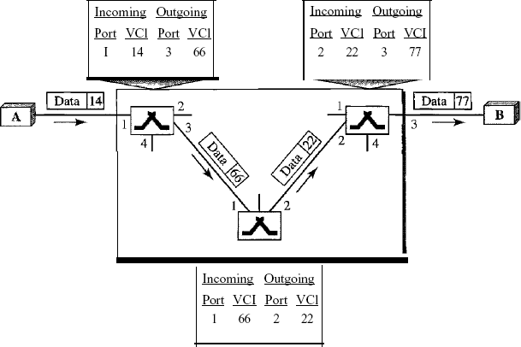

Figure3Source-to-destinationdatatransfer inavirtual-circuitnetwork

Setup Request
A setup request frame is sent fromthe source to the destination. Figure 4 shows the process.
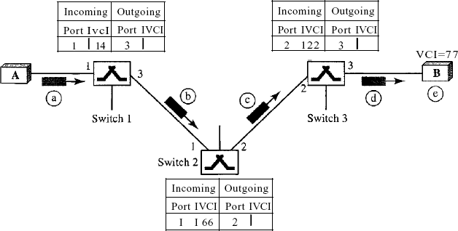

Figure4Setuprequestin avirtual-circuitnetwork
- SourceAsends asetupframetoswitch1.
- Switch 1 receives the setup request frame. It knows that a frame going from A to B goes out throughport3.Howtheswitchhasobtainedthisinformationisapointcoveredinfuture chapters. The switch, in the setup phase, acts as a packet switch; it has a routing table which is different from the switching table. For the moment, assume that it knows the output port. The switch creates an entry in its table for this virtual circuit, but it is only able to fill three of the four columns. The switch assigns the incoming port (1) and chooses an available incoming VCI (14) and the outgoing port (3). It does not yet know the outgoing VCI, which will be found during
theacknowledgmentstep.The switchthenforwards theframe throughport3toswitch2.
- Switch 2 receives the setup request frame. The same events happen here as at switch 1; three columns of the table are completed: in this case, incoming port (l), incoming VCI (66), and outgoing port (2).
- Switch 3 receives the setup request frame. Again, three columns are completed: incoming port (2), incoming VCI (22), and outgoing port (3).

- Destination B receives the setup frame, and if it is ready to receive frames from A, it assigns a VCItotheincomingframesthatcomefromA,inthiscase77.ThisVCI letsthedestination know that the frames come from A, and not other sources.

Acknowledgment A special frame, called the acknowledgment frame, completes the entries inthe switching tables. Figure 8.15 shows the process.
- The destination sends an acknowledgment to switch 3. The acknowledgment carries the global source and destination addresses so the switch knows which entry in the table is to be completed. TheframealsocarriesVCI77,chosenbythedestinationastheincomingVCIforframesfrom
A.Switch3usesthisVCI tocompletetheoutgoingVCIcolumnforthisentry.Notethat77is the incoming VCI for destination B, but the outgoing VCI for switch 3.
- Switch 3 sends an acknowledgment to switch 2 that contains its incoming VCI in the table, chosen in the previous step. Switch 2 uses this as the outgoing VCI in the table.
- Switch 2 sends an acknowledgment to switch 1 that contains its incoming VCI in the table, chosen in the previous step. Switch 1 uses this as the outgoing VCI in the table.
- Finally switch 1 sends an acknowledgment to source A that contains its incoming VCI in the table, chosen in the previous step.
- The source usesthisastheoutgoingVCI forthedataframestobesenttodestinationB.

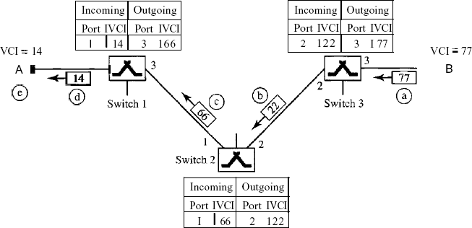

Figure5Setup acknowledgmentsinavirtual-circuitnetwork

TeardownPhase
In this phase, source A, after sending all frames to B, sends a special frame called a teardown request. Destination B responds with a teardown confirmation frame. All switches delete the corresponding entry from their tables.

Efficiency
Aswe said before,resource reservation in a virtual-circuit network can bemade during the setup or can be on demand during the data transfer phase. In the first case, the delay for each packet is the same; in the second case, each packet may encounter different delays. There is one big advantage in a virtual-circuit network even ifresource allocation is on demand. The sourcecan check the availability of the resources, without actually reserving it. Consider a family that wants to dine at a restaurant. Although the restaurantmay not accept reservations (allocation ofthe tables is on demand), the family can call and find out the waiting time. This can save thefamily time and effort.

DelayinVirtual-CircuitNetworks
In a virtual-circuit network, there is a one-time delay for setup and a one-time delay for teardown. If resources are allocated during the setup phase, there is no wait time for individual packets. Below Figure shows the delay for a packet traveling through two switches in a virtual- circuit network.
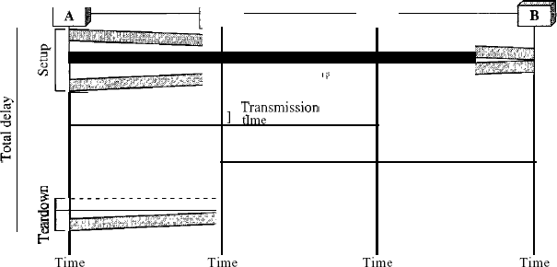

Fig:Delayinavirtual-circuitnetwork

The packet is traveling through two switches (routers). There are three transmission times (3T), three propagation times (3't), data transfer depicted by the sloping lines, a setup delay (which includes transmission and propagation in two directions), and a teardown delay (which includes transmissionandpropagationinonedirection).Weignore the processing time ineachswitch. The total delay time is
Totaldelay=3T+3't+setupdelay+teardowndelay

UNIT –III

Framing:
To provide service to the network layer, the data link layer must use theservice provided to it by the physical layer. What the physical layer does is accept a raw bit stream and attempt to deliver it to the destination. This bit stream is not guaranteed to be error free. The number of bits received may be less than, equal to, or more than the number of bits transmitted, and they may have different values. It is up to the data link layer to detect and, if necessary, correct errors. The usual approach is for the data link layer to break the bit stream up into discrete frames and compute the checksum for each frame. When a frame arrives at the destination, the checksum is recomputed.If the newly computed checksum isdifferent from the one contained in the frame,the data link layerknowsthatanerror hasoccurredandtakesstepstodealwith it(e.g., discarding the bad frame and possibly also sending back an error report).
Breaking thebitstreamupintoframesismoredifficultthanitatfirstappears.One way to achieve thisframing istoinserttimegapsbetweenframes,muchlikethespacesbetweenwords in ordinary text. However, networks rarely make any guarantees about timing, so it is possible these gaps might be squeezed out or other gaps might be inserted during transmission. Since it is too risky to count on timing to mark the start and end of each frame, other methods have been devised. We will look at four methods:
- Charactercount.
- Flagbyteswith bytestuffing.
- Startingandending flags,withbitstuffing.
- Physicallayercodingviolations.
Thefirstframingmethodusesafieldintheheadertospecifythenumberofcharactersinthe frame.Whenthedata linklayeratthedestinationseesthecharactercount,itknowshowmany characters follow and hence where the end of the frame is. This technique is shown in Fig.3.1(a) for four frames of sizes 5, 5, 8, and 8 characters, respectively.

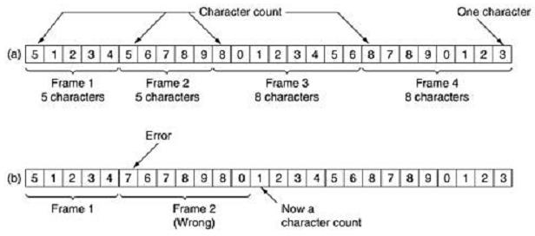

Fig.3.1 Acharacterstream.(a) Withouterrors.(b)Withoneerror.
The trouble with this algorithm is that the count can be garbled by a transmission error. For example, ifthe character countof5inthesecondframeofFig.3.1(b) becomesa 7,the destination will get out of synchronization and will be unable to locate the start of the next frame. Even if thechecksum isincorrect sothe destinationknowsthattheframe isbad, itstill has no way of telling where the next frame starts. Sending a frame back to the source asking for a retransmission does not help either, since the destination does not know how many characters to skip over to get to the start of the retransmission. For this reason, the character count method is rarely used anymore.
Thesecondframing methodgetsaroundtheproblem ofresynchronizationafteranerrorby havingeachframestartandendwithspecialbytes.Inthepast,thestartingandendingbytes were different, but in recent years most protocols have used the same byte, called a flag byte, as both the starting and ending delimiter, as shown in Fig. 3.2(a) asFLAG.In this way,if the receiver ever loses synchronization, it can just search for theflag byte to find the end of thecurrent frame. Two consecutive flag bytes indicate the end of one frame and start of the next one.

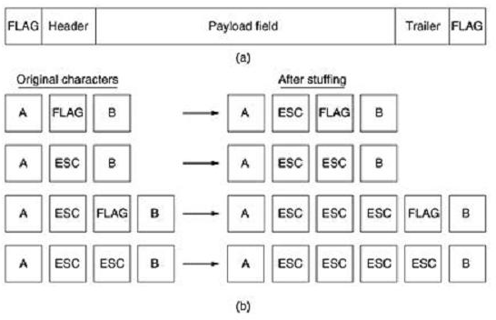

Fig. 3.2 (a) A frame delimited by flag bytes (b) Four examples of byte sequences before and after byte stuffing.

Aseriousproblemoccurswiththismethodwhenbinarydata,suchasobjectprogramsor floating-point numbers, are being transmitted. It may easily happen that the flag byte's bit pattern occurs in the data. This situation will usually interfere with the framing. One way to solve this problem is to have the sender's data link layer insert a special escape byte (ESC) just before each ''accidental'' flag byte inthe data.The data linklayeronthereceivingendremovestheescape byte before the data are given to the network layer. This technique is called byte stuffing or character stuffing. Thus, a framing flag byte can be distinguished from one in the data by the absence or presence of an escape byte before it.
Of course, the next question is: What happens if an escape byte occurs in the middle of the data? The answeristhatit,too,isstuffedwithanescapebyte.Thus,any singleescapebyteispartof anescapesequence,whereasadoubledone indicatesthatasingleescapeoccurrednaturally in the data. Some examples are shown in Fig. 3.3(b). In all cases, the byte sequence delivered afterde stuffing is exactly the same as the original byte sequence.
The byte-stuffing scheme depicted in Fig. 3.3 is a slight simplification of the one used in the PPP protocol that most home computers use to communicate with their Internet service provider.

A major disadvantage of using this framing method is that it is closely tied to the use of 8-bit characters. Not all character codes use 8-bit characters. For example UNICODE uses 16-bit characters, As networks developed, the disadvantages of embedding the character code length in the framing mechanism became more and more obvious, so a new technique had to be developed to allow arbitrary sized characters.
Thenewtechniqueallowsdataframestocontainanarbitrarynumberofbitsandallows character codes with an arbitrary number of bits per character. It works like this. Each framebegins and ends with a special bit pattern, 01111110 (in fact, a flag byte). Whenever the sender's data link layer encounters five consecutive 1s in the data, it automatically stuffs a 0 bit into the outgoing bit stream. This bit stuffing is analogous to byte stuffing, in which an escape byte is stuffed into the outgoing character stream before a flag byte in the data.
When the receiver sees five consecutive incoming 1 bits, followed by a 0 bit, it automatically de stuffs(i.e.,deletes)the0bit.Justasbytestuffingiscompletely transparenttothenetwork layer inbothcomputers,soisbitstuffing.Ifthe user data containtheflag pattern,01111110,thisflag is transmitted as 011111010 but stored in the receiver's memory as 01111110.
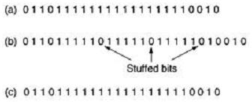

Figure 3.3 Bit stuffing. (a) The original data. (b) The data as they appear on the line. (c) The data as they are stored in the receiver's memory after destuffing.

Withbitstuffing,theboundarybetweentwoframescanbeunambiguouslyrecognizedbythe flag pattern.Thus,ifthereceiverlosestrackofwhereitis,allithastodoisscantheinputfor flag sequences, since they can only occur at frame boundaries and never within the data. The last method of framing is only applicable to networks in which the encoding on the physical medium contains someredundancy.For example, some LANs encode 1bitofdata by using 2physical bits. Normally, a 1 bit is a high-low pair and a 0 bit is a low-high pair. The scheme means that everydatabithasatransitioninthemiddle,makingiteasyforthereceivertolocatethebit

boundaries. The combinations high-high and low-low are not used for data but are used for delimiting frames in some protocols.
As a final note on framing, manydata link protocols use combination of a character count with one of the other methods for extra safety. When a frame arrives, the count field is used to locate the end of the frame. Only if the appropriate delimiter is present at that position and the checksum is correct is the frame accepted as valid. Otherwise, the input stream is scanned for the next delimiter.

Errorcorrectionand detectionatthedatalinklayer.

    - Error-CorrectingCodes:
Network designers have developed two basic strategies for dealing with errors. One way is to include enoughredundantinformationalongwitheachblock ofdatasent,toenablethereceiver to deduce what the transmitted data must have been. The other way is to include only enough redundancy toallowthereceivertodeducethatanerroroccurred,butnotwhicherror,andhave it request a retransmission. The former strategy uses error-correcting codes and the latter uses error-detecting codes. The use of error-correcting codes is often referred to as forward error correction.
Each of these techniques occupies a different ecological niche. On channels that are highlyreliable, such asfiber,it is cheaper to use anerror detecting code and just retransmitthe occasionalblockfoundtobefaulty.However,onchannelssuchaswirelesslinksthatmake many errors, it is better to add enough redundancy to each block for the receiver to be able tofigure outwhatthe original blockwas,rather thanrelying onaretransmission,whichitself may be in error.
Tounderstandhowerrorscanbehandled,itisnecessary tolookcloselyatwhatanerrorreally is.Normally, aframeconsistsofm data(i.e.,message) bitsandrredundant, or check,bits.Let the total length be n (i.e., n = m + r). An n-bit unit containing data and check bits is often referred to as an n-bit codeword.
Given any two code words, say, 10001001 and 10110001, it is possible to determine how many correspondingbitsdiffer.Inthiscase,3bitsdiffer.Todeterminehowmanybitsdiffer,just exclusive OR the two code words and count the number of 1 bits in the result, for example:

The number of bit positions in which two code words differ is called the Hamming distance. Its significance is that if two codewords are a Hamming distance d apart, it will require d single-bit errors to convert one into the other.
Inmostdatatransmissionapplications,all2m possibledatamessagesare legal,butduetothe way the check bits are computed, not all of the 2n possible codewords are used. Given the algorithm for computing the check bits, it is possible to construct a complete list of the legal codewords,andfromthislistfindthetwocodewordswhoseHammingdistanceisminimum. This distance is the Hamming distance of the complete code. The error-detecting and error correcting properties of a code depend on its Hamming distance. To detect d errors, you need a distance d + 1 code because with such a code there is no waythat d single-bit errors can change a valid codeword into another valid codeword. When the receiver sees an invalid codeword, it can tell that a transmissionerror has occurred. Similarly, to correct derrors,you need a distance 2d+1code becausethatway thelegalcodewordsare sofarapart thatevenwithd changes,the original codeword is still closer than any other codeword, so it can be uniquely determined. As a simpleexampleofanerror-detectingcode,consideracodeinwhichasingleparity bappended to the data. The parity bit is chosen so that the number of 1 bits in the codeword is even (or odd). For example, when 1011010 is sent in even parity, a bit is added to the end to make it 10110100. With odd parity 1011010 becomes 10110101. A code with a single parity bit has a distance 2,since any single-bit error produces a codeword with the wrong parity. It can be used to detect single errors.
Asasimpleexampleofanerror-correctingcode,consideracodewithonly fourvalid codewords: 0000000000, 0000011111, 1111100000, and 1111111111
This code has a distance 5, which means that it can correct double errors. If the codeword 0000000111 arrives, the receiver knows that the original must have been 0000011111. If,however, a triple error changes 0000000000 into 0000000111, the error will not be corrected properly.
Imagine that we want to design a code with m message bits and r check bits that will allow all single errors to be corrected. Each of the 2m legalmessages has n illegal codewords at a distance1 from it. These are formed by systematically inverting each of the n bits in the n-bit codeword formed from it. Thus, each of the 2m legal messages requires n + 1 bit patterns dedicated to it. Since the total number of bit patterns is 2n, we must have (n + 1)2m ≤ 2n.

Using n = m + r, this requirement becomes (m + r + 1) ≤ 2r. Given m, this puts a lower limit on the number of check bits needed to correct single errors. This theoretical lower limit can, in fact, be achieved using a method due to Hamming (1950).
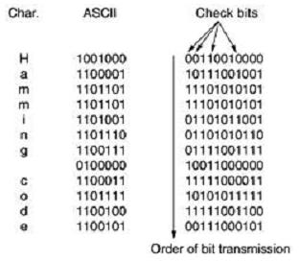
Thebitsofthecodewordarenumberedconsecutively,starting withbit1attheleftend,bit2to itsimmediateright,andsoon.The bitsthat arepowers of 2(1,2,4,8,16,etc.) arecheck bits. The rest (3, 5, 6, 7, 9, etc.) are filled up with the m data bits. Each check bit forces the parity of some collection of bits, including itself, to be even (or odd). A bit may be included in severalparity computations. Toseewhich check bits thedata bit in position k contributesto,rewrite k asa sum of powers of 2.For example, 11 =1 +2 +8 and 29= 1+4+ 8+16.A bitischecked by justthosecheckbitsoccurring initsexpansion(e.g.,bit11ischeckedby bits1,2,and8).When acodewordarrives,thereceiverinitializesacountertozero.Itthenexamineseachcheckbit,k (k = 1, 2, 4, 8 ...), to see if it has the correct parity. If not, the receiver adds k to the counter. If the counter is zero after all the check bits have been examined (i.e., if they were all correct), the codewordisaccepted asvalid.If the counter is nonzero, it containsthe number of theincorrect bit. For example, if check bits 1, 2, and 8 are in error, the inverted bit is 11, because it is the only one checked by bits 1, 2, and 8. Figure 4.1 shows some 7-bit ASCII characters encoded as 11-bit codewordsusingaHammingcode.Rememberthatthedataarefoundinbitpositions3,5,6,7, 9, 10, and 11.

Fig.4.1.Useof aHammingcodetocorrectburst errors

Hamming codescanonlycorrectsingleerrors.However,thereisatrickthatcanbeusedto permit Hamming codes to correct burst errors. A sequence of k consecutive code words isarranged as a matrix, one codeword per row. Normally, the data would be transmitted one codeword at a time, from left to right. To correct burst errors, the data should be transmitted one column at a time, starting with the leftmost column. When all k bits have been sent, the second column is sent, and so on, as indicated in Fig.4.1. When the frame arrives at the receiver, thematrix is reconstructed, one column at a time. If a burst error of length k occurs, at most 1 bit in each of the k codewords will have been affected, but the Hamming code can correct one error per codeword, so the entire block can be restored. This method uses kr check bits to make blocks ofkm data bits immune to a single burst error of length k or less.

Error-DetectingCodes:
Error-correcting codes are widely used on wireless links, which are notoriously noisy and error pronewhencomparedtocopperwireor opticalfibers.Withouterror-correcting codes,itwould behardtogetanythingthrough.However,overcopperwireorfiber,theerrorrateismuch lower, so error detection and retransmission is usually more efficient there for dealing with the occasional error. As a simple example, consider a channel on which errors are isolated and the error rate is 10-6 per bit. Let the block size be 1000 bits. To provide error correction for 1000-bit blocks, 10 check bits are needed; a megabit of data would require 10,000 check bits. To merely detect a block with a single 1-bit error, one parity bit per block will suffice. Once every 1000 blocks, an extra block (1001 bits) will have to be transmitted. The total overhead for the error detection + retransmission method is only 2001 bits per megabit of data, versus 10,000 bits for a Hamming code.
If a single parity bit is added to a block and the block is badly garbled by a long burst error, the probability that the error will be detected is only 0.5, which is hardly acceptable.
The oddscan be improved considerably if each block to be sentisregarded as rectangular matrixn bits wide and k bits high, as described above. A parity bit is computed separately for each columnandaffixedtothematrixasthelastrow.Thematrixisthentransmittedonerowata time. When the block arrives, the receiver checks all the parity bits. If any one of them is wrong, the receiver requests a retransmission of the block. Additional retransmissions are requested as needed until an entire block is received without any parityerrors. This method can detect a single burstoflengthn,sinceonly 1bitpercolumnwillbechanged.Aburstoflengthn+1willpass

undetected, however, if the first bit is inverted, the last bit is inverted, and all the other bits are correct.(A burst error does not imply thatallthe bitsare wrong; it just implies thatatleast the firstandlastarewrong.)Iftheblockisbadly garbledby along burstorby multipleshorter bursts,theprobability thatany ofthencolumnswillhavethecorrectparity,by accident,is0.5, so the probabilityof a bad block being accepted when it should not be is 2-n. Although the above cheme may sometimes be adequate, in practice, another method is in widespread use: the olynomial code, also known as a CRC (Cyclic Redundancy Check).
Polynomial codes are based upon treating bit strings as representations of polynomials with coefficientsof0and1only.Ak-bitframeisregardedasthecoefficientlistforapolynomial with k terms, ranging from xk-1 to x0. Such a polynomial is said to be of degree k - 1. The highorder(leftmost)bitisthecoefficientofxk-1;thenextbitisthecoefficientofxk-2,andso on.For example, 110001 has 6 bits and thus represent a six-term polynomial with coefficients 1,1, 0, 0, 0, and 1: x5 + x4 + x0.
Polynomialarithmetic isdone modulo 2,according totherules ofalgebraicfieldtheory.There are no carries for addition or borrowsfor subtraction. Both addition and subtraction are identicalto exclusive OR. For example: Long division is carried out the same way as it is in binary except that the subtraction is done modulo 2, as above. A divisor is said ''to go into'' a dividend if the dividend has as many bits as the divisor. When the polynomial code method is employed, the sender andreceivermustagreeuponageneratorpolynomial,G(x),inadvance.Boththe high- and low-order bits of the generator must be 1. To compute the checksum for some frame with m bits, corresponding to the polynomial M(x), the frame must be longer than the generator polynomial. The idea is to append a checksum to the end of the frame in such a way that the polynomial represented by the checksummed frame is divisible by G(x). When the receiver getsthe checksummed frame, it tries dividing it by G(x). If there is a remainder, there has been a transmission error.
Thealgorithmforcomputingthechecksum isasfollows:
- Let r be the degree of G(x). Append r zero bits to the low-order end of the frame so it now contains m + r bits and corresponds to the polynomial xr M(x).
- Divide the bit string corresponding to G(x) into the bit string corresponding to xr M(x), using modulo 2 division.

- Subtract the remainder (which is always r or fewer bits) from the bit stringcorrespondingto xr M(x) using modulo 2 subtractions. The result is the checksummed frame to be transmitted. Callits polynomial T(x).
Figureillustratesthecalculationforaframe 1101011011usingthegeneratorG(x)=x4+x+1.
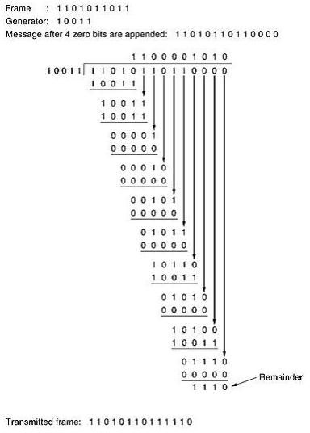
Fig.5.1. Calculationofthepolynomialcode checksum

  - ElementaryData LinkLayerProtocols
    - AnUnrestrictedSimplexProtocol:
As an initial example we will consider a protocol that is as simple as it can be. Data aretransmitted in one direction only. Both the transmitting and receiving network layers are always ready. Processing time can be ignored. Infinite buffer space is available. And best of all, the communication channel between the data link layers never damages or loses frames. This thoroughly unrealistic protocol, which we will nickname ''utopia'' .
The protocol consists of two distinct procedures, a sender and a receiver. The sender runs in the datalinklayerofthesourcemachine,andthereceiverrunsinthedatalinklayerofthe destinationmachine.Nosequencenumbersoracknowledgementsareusedhere,soMAX_SEQ is not needed. The only event type possible is frame_arrival (i.e., the arrival of an undamaged frame).
The sender is in an infinite while loop just pumping data out onto the line as fast as it can. The body of the loop consists of three actions: go fetch a packet from the (always obliging) network layer, construct an outbound frame using the variable s, and send the frame on its way. Only the info field of the frame is used by this protocol, because the other fields have to do with error and flow control and there are no errors or flow control restrictions here. The receiver is equallysimple. Initially, it waits for something to happen, the only possibility being the arrival of an undamaged frame. Eventually, the frame arrives and the procedure wait_for_event returns, with event set to frame_arrival (which is ignored anyway). The call tofrom_physical_layer removesthe newly arrived frame from the hardware buffer and puts it in the variable r, where the receiver code can get at it. Finally, the data portion is passed on to the network layer, and the data linklayer settles back to wait for the next frame, effectively suspending itself until the frame arrives.

ASimplex Stop-and-WaitProtocol:
The main problem we have to deal with here is how to prevent the sender from flooding the receiver with data faster than the latter isable to process them.In essence, ifthe receiver requiresa time ∆t to execute from_physical_layer plus to_network_layer, the sender must transmit at an average rate less than one frame per time ∆t. Moreover, if we assume that no automatic buffering and queuing are done within the receiver's hardware, the sender must never transmit a new frame untiltheoldonehasbeenfetchedbyfrom_physical_layer,lestthenewoneoverwritetheold

one. In certain restricted circumstances (e.g., synchronous transmission and a receiving data link layerfully dedicatedtoprocessing the oneinputline),itmight be possible for thesender to simply insert a delay into protocol 1 to slow it down sufficiently to keep from swamping the receiver. However, more usually, each data link layer will have several lines to attend to, and the time interval between a frame arriving and its being processed may vary considerably. If the network designers can calculate the worst-case behavior of the receiver, they can program the sender to transmit so slowlythat even if every frame suffers the maximum delay, there will be no overruns. The trouble with this approach is that it is too conservative. It leads to a bandwidth utilizationthatisfarbelowtheoptimum,unlessthebestandworstcasesarealmostthesame (i.e., the variation in the data link layer's reaction time is small).
A more general solution to this dilemma is to have the receiver provide feedback to the sender. After having passed a packet to its network layer, the receiver sends a little dummy frame back to the sender which, in effect, gives the sender permission to transmit the next frame. After having sent a frame, the sender is required by the protocol to bide its time until the little dummy (i.e., acknowledgement) frame arrives. Using feedback from the receiver to let the sender know when it may send more data is an example of the flow control mentioned earlier.
Protocols in which the sender sends one frame and then waits for an acknowledgement before proceeding are called stop-and-wait.

ASimplexProtocolforaNoisyChannel:

Protocols in which the sender waits for a positive acknowledgement before advancing to the next data item are often called PAR (PositiveAcknowledgement with Retransmission) orARQ (Automatic Repeat reQuest). Like protocol 2, this one also transmits data only in one direction.

UNIT–IV

SlidingWindowProtocols:
In the previous protocols, data frames were transmitted in one direction only. In most practical situations,thereisaneedfortransmitting datainbothdirections.Oneway ofachieving fullduplexdatatransmissionistohavetwoseparatecommunicationchannelsanduseeachone for simplex data traffic (in different directions). If this is done, we have two separate physical circuits,eachwitha''forward''channel(fordata)anda''reverse''channel(for acknowledgements).Inbothcasesthebandwidthofthereversechannelisalmostentirely wasted. In effect, the user is paying for two circuits but using only the capacity of one. A better idea is to use the same circuit for data in both directions. After all, in protocols 2 and 3 it was already being usedtotransmitframesbothways,andthereversechannelhasthesamecapacity as the forward channel. In this model the data frames from A to B are intermixed with the acknowledgement frames from A to B. By looking at the kind field in the header of an incoming frame, the receiver can tell whether the frame is data or acknowledgement.
Althoughinterleavingdataandcontrolframesonthesamecircuitisanimprovement over having two separate physical circuits, yet another improvement is possible. When a data framearrives,insteadofimmediately sending aseparatecontrolframe, thereceiverrestrains itself andwaitsuntil the network layer passesit the next packet. The acknowledgement is attached to the outgoing data frame (using the ack field in the frame header). In effect, the acknowledgement gets a free ride on the next outgoing data frame. The technique of temporarily delaying outgoing acknowledgements so that they can be hooked onto the next outgoing data frame is known as piggybacking. The principal advantage of using piggybacking over having distinctacknowledgementframesisabetteruseoftheavailable channelbandwidth.Theack fieldintheframeheadercostsonly afewbits,whereasaseparateframewouldneedaheader, the acknowledgement, and a checksum. In addition, fewer frames sent means fewer ''framearrival'' interrupts, and perhaps fewer buffers in the receiver, depending on how the receiver's software is organized. In the next protocol to be examined, the piggyback field costs only1 bit in

the frame header. It rarely costs more than a few bits.
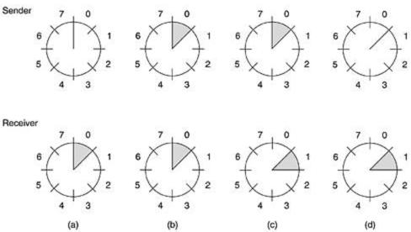

Fig.8.A sliding window of size 1, with a 3-bit sequence number (a) Initially (b) After the first frame has been sent (c) After the first frame has been received (d) After the first acknowledgement has been received.
Since frames currently within the sender's window may ultimately be lost or damaged in transit,the sender must keep all these frames in its memory for possible retransmission. Thus, if the maximumwindowsizeisn,thesenderneedsnbufferstoholdtheunacknowledgedframes.If thewindowevergrowstoitsmaximumsize,thesending datalinklayermustforcibly shutoff the network layer until another buffer becomes free. The receiving data link layer's window corresponds to the frames it may accept. Any frame falling outside the window is discarded without comment. When a frame whose sequence number is equal to the lower edge of thewindow is received, it is passed to the network layer, an acknowledgement is generated, and the windowisrotated by one.Unlike the sender'swindow,the receiver'swindow alwaysremains at its initial size. Note that a window size of 1 means that the data link layer only accepts frames in order, butfor larger windows this is not so. Thenetwork layer, in contrast, is alwaysfed data in the proper order,regardlessof the data link layer'swindow size.Figure 8showsan examplewithamaximumwindowsizeof1.Initially,noframeareoutstanding,sothelowerandupperedges of the sender’s window are equal, but as time goes on, the situation progresses as shown.

AOne-Bit SlidingWindow Protocol:
Before tackling the general case, let us first examine a sliding window protocol with a maximumwindowsize of 1.Such a protocol usesstop-and-waitsincethe sender transmitsa frame and waits for its acknowledgement before sending the next one. Figure 9.1 depicts such a protocol.Liketheothers,itstartsoutby defining somevariables.Next_frame_to_sendtells whichframethesenderistryingtosend.Similarly,frame_expectedtellswhichframethe receiver is expecting. In both cases, 0 and 1 are the only possibilities.
Under normal circumstances, one of the two data link layers goes first and transmits the firstframe. In other words, only one of the data link layer programs should contain the to_physical_layer and start_timer procedure callsoutside the mainloop. In the event thatboth datalinklayersstartoffsimultaneously,apeculiarsituationarises,asdiscussedlater.The starting machine fetches the first packet from its network layer, builds aframe from it, and sendsit. When this (or any) frame arrives, the receiving data link layer checks to see if it is a duplicate, just as in protocol 3. If the frame is the one expected, it is passed to the network layer and the receiver's window is slid up. The acknowledgement field contains the number of the last frame received without error. If this number agrees with the sequence number of the frame the sender is trying to send, the sender knows it is done with the frame stored in buffer and can fetch the next packet from its network layer. If the sequence number disagrees, it must continue trying to sendthe same frame. Whenever a frame is received, a frame is also sent back. Now let us examine protocol4toseehowresilientitistopathologicalscenarios.AssumethatcomputerAistrying to send its frame 0 to computer B and that B is trying to send its frame 0 to A. Suppose that A sendsframe to B, but A's timeout interval is a little too short. Consequently, A may time out repeatedly, sending a series of identical frames, all with seq = 0 and ack = 1.
When the first valid frame arrives at computer B, it will be accepted and frame_expected will be set to 1. All the subsequent frames will be rejected because B is now expecting frameswith sequence number 1, not 0. Furthermore, since all the duplicates have ack = 1 and B is still waiting for an acknowledgement of 0, B will not fetch a new packet from its network layer. After every rejected duplicate comes in, B sends A a frame containing seq = 0 and ack = 0. Eventually, one of thesearrivescorrectly atA,causing A tobeginsending the nextpacket.Nocombination of lost frames or premature timeouts can cause the protocol to deliver duplicate packets to either network layer, to skip a packet, or to deadlock.

However, a peculiar situation arises if both sides simultaneously send an initial packet. This synchronizationdifficulty isillustratedbyFig.9.2.Inpart(a),thenormaloperationofthe protocolisshown.In(b)thepeculiarity isillustrated.IfBwaitsforA'sfirstframebefore sending one of its own, the sequence is as shown in (a), and every frame is accepted. However, ifA and B simultaneously initiate communication, their first frames cross, and the data link layers then get into situation (b). In (a) each frame arrival brings a new packet for the network layer;there are no duplicates. In (b) half of the frames contain duplicates, even though there are no transmissionerrors.Similarsituationscanoccurasaresultofprematuretimeouts,evenwhen onesideclearlystartsfirst.Infact,ifmultipleprematuretimeoutsoccur,framesmay besent three or more times.
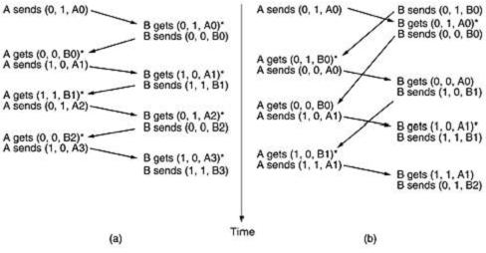
Fig.9.2 Two scenarios for protocol 4 (a) Normal case (b) Abnormal case. The notation is (seq, ack, packet number). An asterisk indicates where a network layer accepts a packet.

    - Selectiverepeat:
AProtocolUsingGoBackN:
Until now we have made the tacit assumption that the transmission time required for a frame to arrive at the receiver plus the transmission time for the acknowledgement to come back is negligible.Sometimesthisassumptionisclearlyfalse.Inthesesituationsthelonground-trip time can have important implications for the efficiency of the bandwidth utilization. As an example, consider a 50-kbps satellite channel with a 500-msec round-trip propagation delay. Let

us imagine trying to use protocol 4 to send 1000-bit frames via the satellite. At t = 0 the sender startssendingthefirstframe.Att=20msectheframehasbeencompletelysent.Notuntilt=
270 msec has the frame fully arrived at the receiver, and not until t = 520 msec has the acknowledgement arrived back at the sender, under the best of circumstances (no waiting in the receiver and a short acknowledgement frame). This means that the sender was blocked during 500/520 or 96 percent of the time. In other words, only 4 percent of the available bandwidth was used. Clearly, the combination of a long transit time, high bandwidth, and short frame length is disastrousintermsofefficiency.Theproblem describedabovecanbeviewed asaconsequence oftherulerequiring asendertowaitforanacknowledgementbeforesending anotherframe.If we relax that restriction, much better efficiency can be achieved. Basically, the solution lies in allowing the sender to transmit up to w frames before blocking, instead of just 1. With an appropriatechoiceofwthesenderwillbeabletocontinuously transmitframesforatimeequal to the round-trip transit time without filling up the window. In the example above, w should be at least 26. The sender begins sending frame 0 as before. By the time it has finished sending 26 frames, at t = 520, the acknowledgement for frame 0 will have just arrived. Thereafter, acknowledgements arrive every 20 msec, so the sender always gets permission to continue just when it needs it. Atalltimes, 25 or 26unacknowledgedframes are outstanding. Put in other terms, the sender's maximum window size is 26.
The need for a large window on the sending side occurs whenever the product of bandwidth x round-trip-delay is large. If the bandwidth is high, even for a moderate delay, the sender will exhaust its window quickly unless it has a large window. If the delay is high (e.g., on a geostationary satellite channel), the sender will exhaust its window even for a moderatebandwidth. The productof these twofactorsbasically tellswhat the capacity ofthe pipe is,and the sender needs the ability to fill it without stopping in order to operate at peak efficiency. This technique isknownas pipelining.Ifthechannelcapacity isb bits/sec,theframe size l bits,and theround-trippropagationtimeRsec,thetimerequiredtotransmitasingleframeisl/bsec. After the last bit of a data frame has been sent, there is a delayof R/2 before that bit arrives at the receiverandanotherdelay ofatleastR/2fortheacknowledgementtocomeback,foratotal delay of R. In stop-and-wait the line is busy for l/band idle for R, giving
Ifl<bR,the efficiencywillbe lessthan50percent.Sincethere isalwaysa nonzerodelayforthe

acknowledgementtopropagate back,pipelining can,inprinciple,beusedtokeep the linebusy during this interval, but if the interval is small, the additional complexityis not worth the trouble. Pipeliningframesoveranunreliablecommunicationchannelraisessomeseriousissues.First, whathappensifaframeinthemiddleofalongstreamisdamagedorlost?Largenumbersof succeedingframeswillarriveatthereceiverbeforethesenderevenfindsoutthatanythingis wrong. When a damaged frame arrives at the receiver, it obviouslyshould be discarded, but what should the receiver do with all the correct frames following it? Remember that the receiving data link layer is obligated to hand packets to the network layer in sequence. In Two basic approaches are available for dealing with errors in the presence of pipelining. Oneway, called go back n, isforthereceiversimply todiscardallsubsequentframes,sending noacknowledgementsforthe discardedframes.Thisstrategy correspondstoareceivewindowofsize1.Inotherwords,the data link layerrefusestoaccept any frameexceptthe next one itmustgiveto the network layer. Ifthesender'swindowfillsupbeforethetimerrunsout,thepipelinewillbegintoempty. Eventually, the sender will time out and retransmit all unacknowledged frames in order, startingwith the damaged or lost one. This approach can waste a lot of bandwidth if the error rate is high. InFig.10.1(a)weseegobacknforthecaseinwhichthereceiver'swindowislarge.
Frames 0 and 1 are correctly received and acknowledged. Frame 2, however, is damaged or lost. Thesender,unawareofthisproblem,continuestosendframesuntilthetimerforframe2 expires. Then it backs up to frame 2 and starts all over with it, sending 2, 3, 4, etc. all over again. The othergeneralstrategy for handlingerrorswhenframesarepipelinediscalled selective repeat.When itisused,a badframe thatisreceived isdiscarded, butgoodframesreceivedafter it are buffered. When the sender times out, only the oldest unacknowledged frame isretransmitted. If that frame arrives correctly, the receiver can deliver to the network layer, in sequence, all the frames it has buffered. Selective repeat is often combined with having the receiver send a negative acknowledgement (NAK) when it detects an error, for example, when it receives a checksum error or a frame out of sequence. NAKs stimulate retransmission before the corresponding timer expires and thus improve performance. In Fig.10.1 (b), frames 0 and 1 are again correctly received and acknowledged and frame 2 is lost. When frame 3 arrives at the receiver, the data link layer there notices that is has missed a frame, so it sends back a NAK for 2 but buffers 3. When frames 4 and 5 arrive, they, too, are buffered bythe data link layer instead of beingpassedtothenetworklayer.Eventually,theNAK2getsbacktothesender,which

immediately resendsframe2.Whenthatarrives,thedatalink layernowhas2,3,4,and5and can pass all of them to the network layer in the correct order. Itcan also acknowledge all framesup to and including 5, as shown in the figure. If the NAK should get lost, eventually the senderwill time outfor frame 2 andsend it (and only it) of its own accord, but that may be a quite awhile later. In effect, the NAK speeds up the retransmission of one specific frame.
Selective repeat corresponds to a receiver window larger than 1. Any frame within the window may be accepted and buffered until all the preceding ones have been passed to the network layer. This approach can require large amounts of data link layer memory if the window is large. These two alternative approaches are trade-offs between bandwidth and data link layer buffer space. Depending on which resource is scarcer, one or the other can be used. Figure 10.2 shows a pipelining protocol in which the receiving data link layer only accepts frames in order; frames following an error are discarded. In this protocol, for the first time we have dropped theassumption that the network layer always has an infinite supply of packets to send. When the network layer has a packet it wants to send, it can cause a network_layer_ready event to happen. However, to enforce the flow control rule of no more than MAX_SEQ unacknowledged frames outstandingatanytime,thedatalinklayermustbeabletokeepthenetworklayerfrom bothering it with more work. The library procedures enable_network_layer and disable_network_layer do this job.

AProtocol UsingSelectiveRepeat
This protocol works well if errors are rare, but if the line is poor, it wastes a lot of bandwidth on retransmitted frames. An alternative strategy for handling errors is to allow the receiver to accept and buffer the frames following a damaged or lost one. Such a protocol does not discard frames merely because an earlier frame was damaged or lost. In this protocol, both sender and receiver maintain a window of acceptable sequence numbers. The sender's window size starts out at 0 and grows to some predefined maximum, MAX_SEQ. The receiver's window, in contrast, is always fixed in size and equal to MAX_SEQ. The receiver has a buffer reserved for each sequencenumber within its fixed window. Associated with each buffer is a bit (arrived) telling whether the bufferisfullorempty.Wheneveraframearrives,itssequencenumberischeckedby the function between tosee if itfallswithin the window.If so and if it has not alreadybeen received,it is accepted and stored. This action is taken without regard to whether or not it contains the next

packetexpectedby thenetworklayer.Ofcourse,itmustbekeptwithinthedatalinklayerand not passed to the network layer until all the lower-numberedframes havealready been deliveredto the network layer in the correct order.

HDLC—High-LevelDataLinkControl:
Theseareagroupofcloselyrelatedprotocolsthatareabitoldbutarestillheavily used.They are all derived from the data link protocol first used in the IBM mainframe world: SDLC (Synchronous Data Link Control) protocol. After developing SDLC, IBM submitted it to ANSIand ISO for acceptance as U.S. and international standards, respectively. ANSI modified it to become ADCCP (Advanced Data Communication Control Procedure), and ISO modified it to become HDLC (High-level Data Link Control). CCITT then adopted and modified HDLC for its LAP (Link Access Procedure) as part of the X.25 network interface standard but later modified it again to LAPB, to make it more compatible with a later version of HDLC. The nice thing about standards is that you have so many to choose from. Furthermore, if you do not like any of them, you can just wait for next year's model. These protocols are based on the same principles. All are bit oriented, and all use bit stuffing for data transparency. They differ only in minor, but neverthelessirritating,ways.Thediscussionofbit-orientedprotocolsthatfollowsisintendedas a general introduction. For the specific details of any one protocol, please consult the appropriate definition.
All the bit-oriented protocols use the frame structure shown in Fig.11.1. The Address field is primarily of importance on lines with multiple terminals, where it is used to identify one of the terminals. For point-to-point lines, it is sometimes used to distinguish commands from responses.
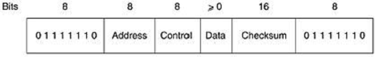

Fig.11.1.Frameformatforbit-oriented protocols
The Control field is used for sequence numbers, acknowledgements, and other purposes, as discussed below.
The Data field may contain any information. It may be arbitrarily long, although the efficiency of thechecksumfallsoffwithincreasing framelengthduetothegreaterprobability ofmultiple burst errors.

TheChecksumfieldisacyclicredundancycode.Theframeisdelimitedwithanotherflag sequence (01111110). On idle point-to-point lines, flag sequences are transmitted continuously. The minimum frame contains three fields and totals 32 bits, excluding the flags on either end.
Therearethree kinds offrames:Information,Supervisory,andUnnumbered.
ThecontentsoftheControlfieldforthesethreekindsareshowninFig.11.2.The protocol uses a sliding window, with a 3-bit sequence number. Up to seven unacknowledged frames may be outstanding at any instant. The Seq field in Fig.11.2 (a) is the frame sequence number. The Next field is a piggybacked acknowledgement. However, all the protocols adhere to the convention that instead of piggybacking the number of the last frame received correctly, they use the number of the first frame not yet received (i.e., the next frame expected). The choice of using the last frame received or the next frame expected is arbitrary; it does not matter which convention is used, provided that it is used consistently.
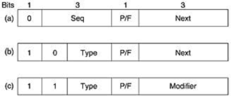

Fig.11.2 Control field of (a) an information frame, (b) a supervisory frame, (c) an unnumbered frame
The P/F bit standsforPoll/Final.It is usedwhena computer(or concentrator) ispolling agroup of terminals. When used as P, the computer is inviting the terminal to send data. All the framessent by the terminal, except the final one, have the P/F bit set to P. The final one is set to F. In some of the protocols, the P/F bit is used to force the other machine to send a Supervisory frame immediately rather than waiting for reverse traffic onto which to piggyback the window information. The bit also has some minor uses in connection with the Unnumbered frames.
The various kinds of Supervisory frames are distinguished by the Type field. Type 0 is an acknowledgement frame (officially called RECEIVE READY) used to indicate the next frame expected. This frame is used when there is no reverse traffic to use for piggybacking.

Type1is a negative acknowledgement frame (officially called REJECT). It is used to indicatethat a transmissionerror has been detected. TheNext field indicates thefirstframe in sequence not received correctly (i.e., the frame to be retransmitted). The sender is required to retransmit all outstanding frames starting at Next. This strategy is similar to our protocol 5 rather than our protocol 6.
Type2isRECEIVENOTREADY.ItacknowledgesallframesuptobutnotincludingNext, just as RECEIVE READY does, but ittellsthe sender to stopsending. RECEIVE NOT READYis intended to signal certain temporary problems with the receiver, such as a shortage of buffers, and not as an alternative to the sliding window flow control. When the condition has beenrepaired, the receiver sends a RECEIVE READY, REJECT, or certain control frames.
Type3istheSELECTIVE REJECT.Itcallsforretransmissionof only the frame specified.In this sense it is like our protocol 6 rather than 5 and is therefore most useful when the sender's window size is half the sequence space size, or less. Thus, if a receiver wishes to buffer out- of- sequence frames for potential future use, it can force the retransmission of any specific frameusing Selective Reject. HDLC and ADCCP allow this frame type, but SDLC and LAPB do not allow it (i.e., there is no Selective Reject), and type 3 frames are undefined.
The third class of frame is the Unnumbered frame. It is sometimes used for control purposes but can also carry data when unreliable connectionless service is called for. The various bit-oriented protocols differ considerably here, in contrast with the other two kinds, where they are nearly identical. Five bits are available to indicate the frame type, but not all 32 possibilities are used.

PPP-ThePoint-to-Point Protocol:
The Internet needs a point-to-point protocol for a varietyof purposes, including router-to- router traffic and home user-to-ISP traffic. This protocol is PPP (Point-to-Point Protocol), whichis defined in RFC 1661 and further elaborated on in several other RFCs (e.g., RFCs 1662 and 1663). PPP handles error detection, supports multiple protocols, allows IP addresses to be negotiated at connection time, permits authentication, and has many other features.
PPPprovidesthreefeatures:
1. A framing method that unambiguouslydelineates the end of one frame and the start of the next one. The frame format also handles error detection.

- A link control protocol for bringing lines up, testing them, negotiating options, and bringing them down again gracefully when they are no longer needed. This protocol is called LCP (Link Control Protocol). It supports synchronous and asynchronous circuits and byte-oriented and bit- oriented encodings.
- A way to negotiate network-layer options in a way that is independent of the network layer protocol to be used.The methodchosen istohave a differentNCP(Network ControlProtocol) for each network layer supported.
To see how these pieces fit together, let us consider the typical scenario of a home user callingupanInternetserviceprovidertomakeahomePCatemporaryInternethost.ThePC first calls the provider'srouter viaa modem.After the router's modem has answered the phone and established a physical connection, the PC sends the router a series of LCP packets in the payload field of one or more PPP frames. These packets and their responses select the PPP parameters to be used.
Once the parameters have been agreed upon, a series of NCP packets are sent to configure the network layer. Typically, the PC wants to run a TCP/IP protocol stack, so it needs an IP address. There are notenoughIPaddresses togoaround, so normally eachInternetprovidergets a block of them and then dynamically assigns one to each newly attached PC for the duration of its login session.IfaproviderownsnIPaddresses,itcanhaveuptonmachinesloggedin simultaneously,butitstotalcustomerbasemay bemany timesthat.TheNCPforIPassignsthe IP address. At this point, the PC is now an Internet host and can send and receive IP packets, justas hardwired hosts can. When the user is finished, NCP tears down the network layer connection and frees up the IP address. Then LCP shuts down the data link layer connection. Finally, the computer tells the modem to hang up the phone, releasing the physical layer connection.

The PPPframe formatwas chosen to closely resemble the HDLCframe format,since there was no reason to reinvent the wheel. The major difference between PPP and HDLC is that PPP is characterorientedratherthanbitoriented.Inparticular,PPPusesbytestuffingondial-up modem lines, so all frames are an integral number of bytes. It is not possible to send a frame consisting of 30.25 bytes, as it is with HDLC. Not only can PPP frames be sent over dialup telephone lines, but they can also be sent over SONET or true bit-oriented HDLC lines (e.g., for router-router connections). The PPP frame format is shown in Fig.13.

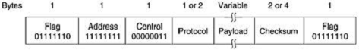

Fig.13. ThePPPfullframeformat forunnumberedmodeoperation
All PPP frames begin with the standard HDLC flag byte (01111110), which is byte stuffed if it occurs within the payload field. Next comes the Address field, which is always set to the binary value 11111111 to indicate that all stations are to accept the frame. Using this value avoids the issue of having to assign data link addresses.

The Address field is followed by the Control field, the default value of which is 00000011. This value indicates an unnumbered frame. In other words, PPP does not provide reliable transmission using sequence numbers and acknowledgements as the default. In noisy environments, such as wireless networks, reliable transmission using numbered mode can be used. The exact details are defined in RFC 1663, but in practice it is rarely used. Since the Address and Control fields are always constant in the default configuration, LCP provides the necessary mechanism for the two parties to negotiate an option to just omit them altogether and save 2 bytes per frame.

The fourth PPP field is the Protocol field. Its job is to tell what kind of packet is in the Payload field. Codes are definedforLCP, NCP, IP,IPX, AppleTalk, and other protocols. Protocols startingwitha0bitarenetworklayerprotocolssuchasIP,IPX,OSICLNP,XNS.Those starting with a 1 bit are used to negotiate other protocols. These include LCP and a different NCP for each network layer protocol supported. The default size of the Protocol field is 2 bytes, but it can be negotiated down to 1 byte using LCP. The Payload field is variable length, up to some negotiated maximum. If the length is not negotiated using LCP during line setup, a default length of 1500 bytes is used. Padding may follow the payload if need be. After the Payload field comes the Checksum field, which is normally 2 bytes, but a 4-byte checksum can be negotiated.

Insummary,PPPisamultiprotocolframing mechanismsuitablefor useovermodems,HDLC bit-serial lines, SONET, and other physical layers. It supports error detection, option negotiation, header compression, and, optionally, reliable transmission using an HDLC type frame format.

RandomAccess:

ALOHA:
Inthe 1970s,NormanAbramson and hiscolleagues at theUniversity ofHawaiidevised a new and elegant method to solve the channel allocation problem. Their work has been extended by many researchers since then (Abramson, 1985).
Although Abramson's work, called the ALOHA system, used ground-based radio broadcasting,the basic idea is applicable to any system in which uncoordinated users are competing for the use of a single shared channel. There are two versions of ALOHA: pure and slotted. They differ with respect to whether time is divided into discrete slots into which all frames must fit. Pure ALOHA does not require global time synchronization; slotted ALOHA does.

Pure ALOHA:
The basic idea of an ALOHA system is simple: let users transmit whenever they have data to be sent. There will be collisions, of course, and the colliding frames will be damaged.However, due to the feedback property of broadcasting, a sender can always find out whether its frame was destroyed by listening to the channel, the same way other users do. With a LAN, the feedback is immediate; with a satellite, there is a delay of 270 msec before the sender knows if thetransmission was successful. If listening while transmitting is not possible for some reason, acknowledgementsareneeded.Iftheframewasdestroyed,thesenderjustwaitsarandom amount of time and sends it again. The waiting time must be random or the same frames will collide over and over, in lockstep. Systems in which multiple users share a common channel in a way that can lead to conflicts are widely known as contention systems.
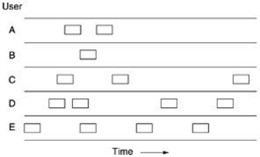
A sketch offramegeneration in an ALOHA system isgiven inFig.1.Wehave made the frames allthesamelengthbecausethethroughputofALOHAsystemsismaximizedby havinga uniform frame size rather than by allowing variable length frames.

Fig.1 In pureALOHA,framesaretransmitted atcompletely arbitrarytimes.

Whenever twoframestry to occupy the channelatthesame time,there willbe acollision and bothwillbegarbled.Ifthefirstbitofanewframeoverlapswithjustthelastbitofaframe almostfinished,bothframeswillbetotallydestroyedandbothwillhavetoberetransmitted later. The checksum cannot (and should not) distinguish between a total loss and a near miss.
Let the''frame time'' denote the amountof timeneeded totransmit the standard, fixedlength frame (i.e., the frame length divided by the bit rate). At this point we assume that the infinite populationofusersgeneratesnewframesaccordingtoaPoissondistributionwithmeanN frames per frame time. (The infinite-population assumption is needed to ensure that N does no decrease as users become blocked.) If N > 1, the user communityis generating frames at a higher rate than the channel can handle, and nearly every frame will suffer a collision. For reasonable throughput we would expect 0 < N < 1. In addition to the new frames, the stations also generate retransmissions of frames that previously suffered collisions. Let us further assume that the probability of k transmission attemptsper frametime, oldand new combined,isalso Poisson, with mean G per frame time. Clearly, G≥N. At low load (i.e., N 0), there will be few collisions, hence few retransmissions, soG N.At high load there willbe many collisions, soG >N. Under allloads,thethroughput,S,isjusttheofferedload,G,timestheprobability,P0,ofa transmission succeeding—that is, S= GP0,where P0 is the probability thata frame does not suffer a collision.
Aframewillnotsufferacollisionifnootherframesaresentwithinoneframe timeofitsstart, as shown in Fig.2.
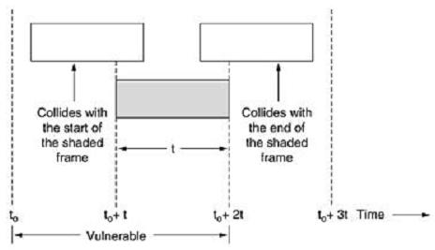

Fig.2.Vulnerableperiodfortheshadedframe

Underwhatconditionswilltheshadedframearriveundamaged?Lettbethe timerequiredto send a frame. If any other user has generated a frame between time t0 and t0+tr, the end of that frame will collide with the beginning of the shaded one. In fact, the shaded frame's fate wasalready sealedevenbeforethefirstbitwas sent,butsince in pureALOHAastationdoesnot listentothechannelbeforetransmitting,ithasnowayofknowingthatanotherframewas already underway. Similarly, any other frame started between t0+t and t0+2t will bump into the end of the shaded frame.
The probability that k frames are generated during a given frame time is given by the Poisson distribution:

Equation
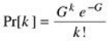

so the probability of zero frames isjust e-G.Inan interval two frame timeslong, the mean number of frames generated is 2G. The probability of no other traffic being initiated during the entire vulnerable period is thus given by P0 = e -2G. Using S = GP0, we get

The relation between the offered traffic and the throughput is shown in Fig. 4-3. The maximum throughputoccursatG=0.5,withS=1/2e,whichisabout0.184.Inotherwords,thebestwe can hope for is a channel utilization of 18 per cent. This result is not very encouraging, but with everyone transmitting at will, we could hardly have expected a 100 per cent success rate.

SlottedALOHA:
In 1972, Roberts published a method for doubling the capacity of an ALOHA system (Robert, 1972). His proposal was to divide time into discrete intervals, each interval corresponding to one frame. This approach requires the users to agree on slot boundaries. One way to achieve synchronization would be to have one special station emit a pip at the start of each interval, like a clock.
In Roberts' method, which has come to be known as slotted ALOHA, in contrast to Abramson's pure ALOHA, a computer is not permitted to send whenever a carriage return istyped. Instead, it is required to wait for the beginning of the next slot. Thus, the continuous pure ALOHA is turned

into a discrete one. Since the vulnerable period is now halved, the probability of no other trafficduring the same slot as our test frame is e-G which leads to

\Equation

As you can see from Fig.3, slotted ALOHA peaks at G = 1, with a throughput of S=1/e or about 0.368,twicethatofpureALOHA.IfthesystemisoperatingatG=1,theprobabilityofan empty slot is 0.368. The best we can hope for using slotted ALOHA is 37 percent of the slots empty, 37 percent successes, and 26 percent collisions. Operating athigher values of G reducesthe number of empties but increases the number of collisions exponentially.
ToseehowthisrapidgrowthofcollisionswithGcomesabout,considerthetransmissionofa test frame. The probability that it will avoid a collision is e-G, the probability that all the other users are silent in that slot. The probabilityof a collision is then just 1 – e-G. The probabilityof a transmission requiring exactly k attempts, (i.e., k – 1 collisions followed by one success) is
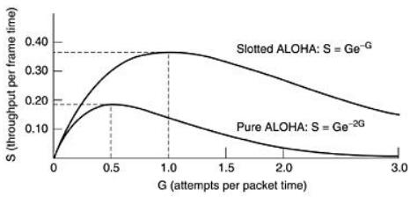

Fig.3ThroughputversusofferedtrafficforALOHAsystems.

The expectednumberoftransmissions,E,percarriage returntypedisthen
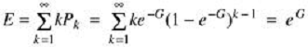
As a result of the exponential dependence of E upon G, small increases in the channel load can drastically reduce its performance.

CSMA

Carrier SenseMultiple Access Protocols:
With slotted ALOHA the best channel utilization that can be achieved is 1/e. This is hardly surprising, since with stations transmitting at will, without paying attention to what the other stations are doing, there are bound to be many collisions. In local area networks, however, it is possibleforstationstodetectwhatotherstationsaredoing,andadapttheirbehaviour accordingly.Thesenetworkscanachieveamuchbetterutilizationthan1/e.Inthissectionwe will discuss some protocols for improving performance. Protocols in which stations listen for a carrier (i.e., a transmission) and act accordingly are called carrier sense protocols. A number of them have been proposed. Kleinrock and Tobagi (1975) have analysed several such protocols in detail. Below we will mention several versions of the carrier sense protocols.

1-persistentCSMA:
The first carrier sense protocol that we will study here is called 1-persistent CSMA(CarrierSense Multiple Access). When a station has data to send, it first listens to the channel to see if anyone else is transmitting at that moment.If the channel is busy, thestation waitsuntil it becomes idle. When the station detects an idle channel, it transmits a frame. If a collision occurs, the station waits a random amount of time and starts all over again. The protocol is called 1- persistent because the station transmits with a probability of 1 when it finds the channel idle.
The propagation delay hasanimportanteffectontheperformance of the protocol.There isa smallchance thatjustaftera stationbeginssending,another stationwillbecomeready tosend and sensethechannel.Ifthefirststation'ssignalhasnotyetreached thesecondone,thelatter will sense an idle channel and will also begin sending, resulting in a collision. The longer the propagation delay, the more important this effect becomes, and the worse the performance of the protocol. Evenifthe propagation delay iszero,therewillstillbe collisions.If twostations become ready in the middle of a third station's transmission, both will wait politely until the transmission ends and then both will begin transmitting exactly simultaneously, resulting in a collision. If they were not so impatient, there would be fewer collisions. Even so, this protocol is far better thanpureALOHAbecause both stations have thedecency todesistfrominterfering with the third station's frame.Intuitively, thisapproach will lead to a higherperformance than pure ALOHA. Exactly the same holds for slotted ALOHA.

Non-persistentCSMA:
A second carrier sense protocol is nonpersistent CSMA. In this protocol, a conscious attempt is made tobelessgreedy thaninthepreviousone. Beforesending,astationsensesthechannel.If nooneelseissending,thestationbeginsdoingsoitself.However,ifthechannelisalready in use, the station does not continually sense it for the purpose of seizing it immediately upon detecting the end of the previous transmission. Instead, it waits a random period of time and then repeats the algorithm. Consequently, this algorithm leads to better channel utilization but longer delays than 1-persistent CSMA.

P-persistentCSMA:
The last protocol is p-persistent CSMA. It applies to slotted channels and works as follows.When a station becomes ready to send, it senses the channel. If it is idle, it transmits with a probability p. With a probability q = 1 - p, it defers until the next slot. If that slot is also idle, It eithertransmitsordefersagain,withprobabilitiespandq.Thisprocessisrepeateduntileither the frame has been transmitted or another station has begun transmitting. In the latter case, the unlucky station acts as ifthere had been a collision (i.e., itwaits arandomtime and starts again).If the station initially senses the channel busy, it waits until the next slot and applies the above algorithm.Figure 4 shows the computed throughput versus offered traffic for all three protocols,as well as for pure and slotted ALOHA.
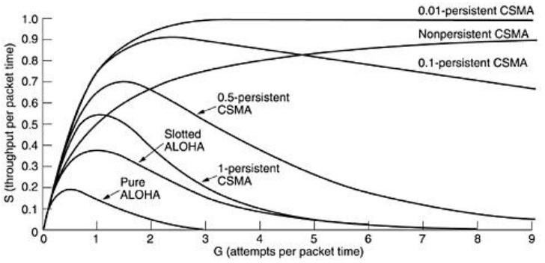

Fig.4 Comparison of the channel utilization versus load for various random access protocols

CSMA withCollisionDetection:
Persistent and nonpersistent CSMA protocols are clearly an improvement over ALOHA because they ensure that no station begins to transmit when it senses the channel busy. Another improvementisforstationstoaborttheirtransmissionsassoonastheydetectacollision.In other words, if two stations sense the channel to be idle and begin transmitting simultaneously, they will both detect the collision almost immediately. Rather thanfinishtransmitting their frames, which are irretrievably garbled anyway, they should abruptly stop transmitting as soon as the collision is detected. Quickly terminating damaged frames saves time and bandwidth.
Thisprotocol,knownasCSMA/CD(CSMAwithCollisionDetection)iswidely usedonLANs in the MAC sublayer. In particular, it is the basis of the popular Ethernet LAN, so it is worth devoting some time to looking at it in detail. CSMA/CD, as well as many other LAN protocols, uses the conceptual model of Fig.5. At the point marked t0, a station has finished transmitting its frame.Any otherstationhaving aframetosendmay nowattempttodoso.Iftwoormore stations decide to transmit simultaneously, there will be a collision. Collisions can be detected by looking at the power or pulse width of the received signal and comparing it to the transmitted signal.
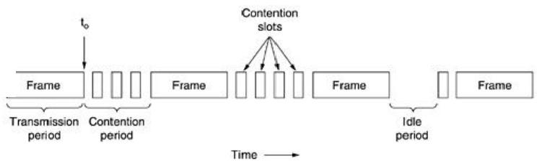

Fig.5. CSMA/CDcanbe in one ofthreestates:contention, transmission,or idleAftera stationdetectsacollision,it abortsitstransmission,waitsa random period oftime, and thentriesagain,assumingthatnootherstationhasstartedtransmittinginthemeantime. Therefore,ourmodelforCSMA/CDwillconsistofalternatingcontentionandtransmission periods, with idle periods occurring when all stations are quiet (e.g., for lack of work).

Now let us look closely at the details of the contention algorithm. Suppose that two stations both begin transmitting at exactly time t0. How long will it take them to realize that there has been a collision? The answer to this question is vital to determining the length of the contention period and hencewhatthe delay and throughputwillbe.Theminimumtime todetectthecollisionis then just the time it takes the signal to propagate from one station to the other.
Based on this reasoning, you might think that a station not hearing a collision for a time equal to thefullcablepropagationtimeafterstartingitstransmissioncouldbesureithadseizedthe cable.By''seized,''wemeanthatallotherstationsknewitwastransmittingandwouldnot interfere.Thisconclusioniswrong. Considerthefollowingworst-casescenario.Letthetimefor a signal to propagate between the two farthest stations be . At t0, one station begins transmitting. At,aninstantbeforethesignalarrivesatthemostdistantstation,thatstationalsobegins transmitting.Ofcourse,itdetectsthecollisionalmostinstantlyandstops,butthelittlenoise burstcausedby thecollisiondoesnotget back totheoriginal stationuntil time .Inotherwords, in the worst case a station cannot be sure that it has seized the channel until it has transmitted for withouthearingacollision.Forthisreasonwewillmodelthecontentionintervalasaslotted ALOHA system with slot width . On a 1-km long coaxial cable, . For simplicity we will assume that each slot contains just 1 bit. Once the channel has been seized, a station can transmit at any rate it wants to, of course, not just at 1 bit per sec.

IEEESTANDARDS
In 1985, the Computer Society of the IEEE started a project, called Project 802, to set standards to enable intercommunication among equipment from a variety of manufacturers.Project 802 does not seek to replace anypart of the OSI or the Internet model.Instead, it is a way of specifying functions of the physical layer and the data link layer of major LAN protocols.
The standard was adopted by the American National Standards Institute (ANSI). In 1987, the International Organization for Standardization (ISO) also approved it as an international standard under the designation ISO 8802. The relationship of the 802 Standard to the traditional OSI model is shown in Figure 1.
The IEEE has subdivided the data link layer into two sublayers: logical link control (LLC) and media access control (MAC).
IEEE hasalso createdseveralphysicallayerstandardsfordifferentLANprotocols.
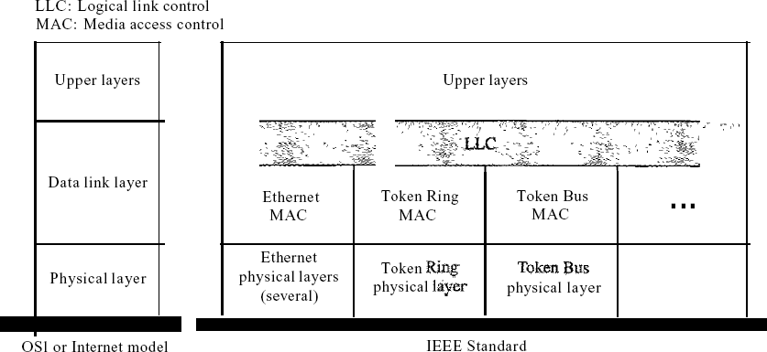

Figure1IEEEstandardforLANs
    - DataLinkLayer
As we mentioned before, the data link layer in the IEEE standard isdivided into twosublayers:LLC and MAC.

LogicalLink Control(LLC)
We said that data link control handles framing, flow control, and error control. In IEEE Project 802, flow control, error control,and part of the framing duties are collected into one sublayercalled the logical link control. Framing is handled in both the LLC sublayer and the MACsublayer.
The LLC provides one single data link control protocol for allIEEELANs.In thisway, theLLC is different from the media access control sublayer, which provides different protocols fordifferent LANs. A single LLC protocol can provide interconnectivity between different LANs because it makes the MAC sublayer transparent. Figure 1 shows one single LLC protocol serving severalMACprotocols.FramingLLCdefinesa protocol data unit(PDU)thatissomewhat similar to that of HDLC. The header contains a control field like the one in HDLC; this field is used for flow and error control. The two other header fields define the upper-layer protocol at the source and destination that uses LLC. These fields are called the destination service access point (DSAP)andthesourceserviceaccesspoint(SSAP).Theotherfieldsdefinedinatypicaldata link control protocol such as HDLC are moved to the MAC sublayer. In other words, a frame definedinHDLCisdividedintoaPDUattheLLCsublayerandaframeattheMACsublayer, as shown in Figure 2.
Need for LLC The purpose of the LLC is to provide flow and error control for the upper-layer protocolsthatactually demandtheseservices.Forexample,ifaLANorseveralLANsareused in an isolated system, LLC may be needed to provide flow and error control for the application layer protocols. However, most upper-layer protocols such as IP, do not use the services of LLC.

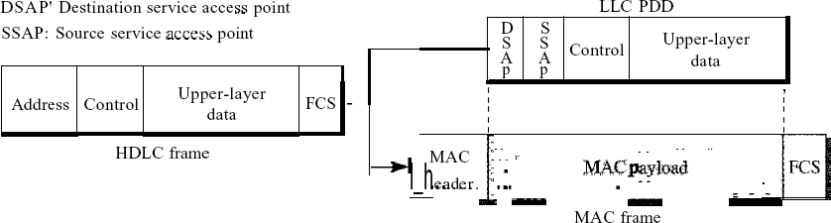
Figure13.2HDLCframecomparedwithLLC andMACframes

MediaAccessControl(MAC)
IEEEProject802hascreatedasublayercalledmediaaccesscontrolthatdefinesthespecific access method for each LAN. For example, it defines CSMA/CD as the media access method for EthernetLANsandthetokenpassingmethodforTokenRingandTokenBusLANs.Aswe discussed in the previous section, part of the framing function is also handled by the MAC layer. In contrast to the LLC sublayer, the MAC sublayer contains a number of distinctmodules; eachdefines the access method and the framing format specific to the corresponding LAN protocol.

Physical Layer
The physical layer is dependent on the implementation and type of physical media used. IEEE definesdetailedspecificationsforeachLANimplementation.Forexample,althoughthereis only oneMACsublayerforStandardEthernet,there isadifferentphysicallayerspecifications for each Ethernet implementations.

StandardEthernet
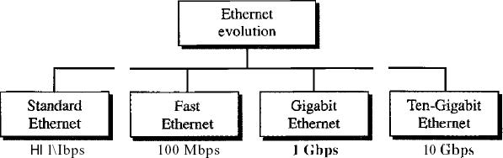

Figure3Ethernetevolutionthroughfourgenerations

MACSublayer
In Standard Ethernet, the MAC sublayer governs the operation of the access method. It alsoframes data received from the upper layer and passes them to the physical layer.
FrameFormat
TheEthernetframecontainssevenfields:preamble,SFD,DA,SA,lengthortypeofprotocol data unit (PDU), upper-layer data, and the CRe. Ethernet does not provide any mechanism for acknowledgingreceivedframes,makingitwhatisknownasanunreliablemedium.

Acknowledgmentsmustbeimplementedatthehigherlayers.TheformatoftheMACframeis shown in Figure 4.
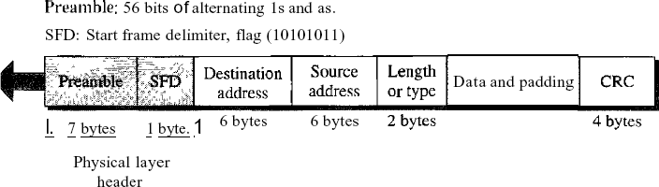
Figure4802.3MACframe

D Preamble. The first field of the 802.3 frame contains 7 bytes (56 bits) of alternating Os andIsthatalertsthe receiving system tothe coming frame andenables ittosynchronize its input timing. The pattern provides only an alert and a timing pulse. The 56-bit pattern allows the stations to miss some bits at the beginning of the frame. The preamble isactually added at the physical layer and is not (formally) part of the frame.
D Start frame delimiter (SFD). The second field (l byte: 10101011) signals the beginningof the frame. The SFD warns the station or stations that this is the last chance for synchronization. The last 2 bits is 11 and alerts the receiver that the next field is the destination address.
Destination address(DA).TheDAfield is 6 bytes and containsthe physical addressof the destination station or stations to receive the packet.
Source address (SA). The SA field is also 6 bytes and contains the physical address of the sender of the packet. We will discuss addressing shortly.
Length or type. This field is defined as a type field or length field. The original Ethernet used this field as the type field to define the upper-layer protocol using the MAC frame. The IEEE standard used it as the length field to define the number of bytes in the datafield. Both uses are common today.
Data. This field carries data encapsulated from the upper-layer protocols. It is a minimum of 46 and a maximum of 1500 bytes.
CRC.Thelastfieldcontainserrordetectioninformation,inthiscaseaCRC-32

FrameLength
Ethernet has imposed restrictions on both the minimum and maximum lengths of a frame, as shown in Figure 5.
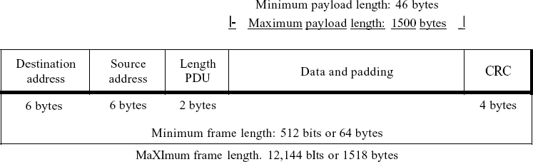

Figure5Minimum andmaximum lengths

The minimum length restriction is required for the correct operation of CSMAlCD. An Ethernet frame needstohavea minimum length of512bitsor64bytes.Part of thislengthisthe header and the trailer. If we count 18 bytes of header and trailer (6 bytes of source address, 6 bytes of destination address, 2 bytes of length or type, and 4 bytes of CRC), then the minimum length of data from the upper layer is 64 - 18 = 46 bytes. If the upper-layer packet is less than 46 bytes, padding is added to make up the difference.
The standard defines the maximum length of a frame (without preamble and SFD field) as 1518 bytes.Ifwesubtractthe18bytesof header andtrailer, themaximumlength of thepayloadis 1500 bytes. The maximum length restriction has two historical reasons. First, memory was very expensivewhenEthernetwasdesigned:amaximumlengthrestrictionhelpedtoreducethesize ofthebuffer.Second,themaximumlengthrestrictionpreventsonestationfrommonopolizing the shared medium, blocking other stations that have data to send.
Framelength:
Minimum:64 bytes(512bits)Maximum:1518 bytes(12,144 bits)

Addressing
Each station on an Ethernet network (such as a PC, workstation, or printer) has its ownnetworkinterfacecard(NIC).TheNICfitsinsidethestationandprovidesthestationwitha6-byte

physicaladdress.AsshowninFigure6,theEthernetaddressis6bytes(48bits),nonnally written in hexadecimal notation, with a colon between the bytes.
06:01:02:01:2C:4B
6bytes=12hexdigits=48bits

Figure 6Example ofanEthernetaddressinhexadecimalnotation

Unicast, Multicast, and Broadcast Addresses A source address is always a unicast address-the frame comesfrom only one station. The destination address,however,canbe unicast, multicast, or broadcast. Figure 7 shows how to distinguish a unicast address from a multicast address. If the least significant bit of the first byte in a destinationaddress is 0, the address is unicast; otherwise,it is multicast.
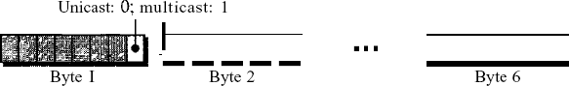

Figure7Unicastandmulticastaddresses

A unicast destination address defines only one recipient; the relationship between the sender and the receiver is one-to-one. A multicast destination address defines a group of addresses; the relationship between the sender and the receivers is one-to-many. The broadcast address is a special case of the multicast address; the recipients are all the stations on the LAN. A broadcast destination address is forty-eight.
    - Physical Layer
The Standard Ethernet defines several physical layer implementations; four of the most common, are shown in Figure 8.
EncodingandDecoding
All standard implementations use digital signaling (baseband) at 10 Mbps. At the sender, data are converted to a digital signal using the Manchester scheme; at the receiver, the received signal is interpreted as Manchester and decoded into data. Manchester encoding is self-synchronous, providing a transition at each bit interval. Figure 9 shows the encoding scheme for Standard Ethernet.

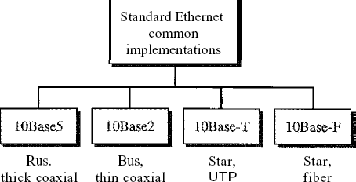

Figure8CategoriesofStandardEthernet

FastEthernet
Fast Ethernet was designed to compete with LAN protocols such as FDDI or Fiber Channel (or Fibre Channel, as it is sometimes spelled). IEEE created Fast Ethernet under the name 802.3u. Fast Ethernet is backward-compatible with Standard Ethernet, but it can transmit data 10 times faster at a rate of 100 Mbps.
ThegoalsofFastEthernetcanbesummarizedasfollows:
- Upgrade the datarateto100Mbps.
- Makeit compatiblewithStandard Ethernet.
- Keepthe same48-bitaddress.
- Keep the sameframeformat.
- Keepthesameminimumandmaximumframelengths.

MACSublayer Physical Layer

IEEE802.11
    - Architecture
The standard defines two kinds of services: the basic service set (BSS) and the extended serviceset (ESS).
BasicService Set
IEEE 802.11 defines the basic service set (BSS) as the building block of a wireless LAN. A basic service set is made of stationary or mobile wireless stations and an optional central base station, known as the access point (AP). Figure 9 shows two sets in this standard.
The BSS without anAP is a stand-alone network and cannot send data to other BSSs.It is calledanadhocarchitecture.Inthisarchitecture,stationscanformanetworkwithouttheneedofan

AP; they can locate one another and agree to bepart of a BSS. ABSS with an AP is sometimesreferred to as an infrastructure network.
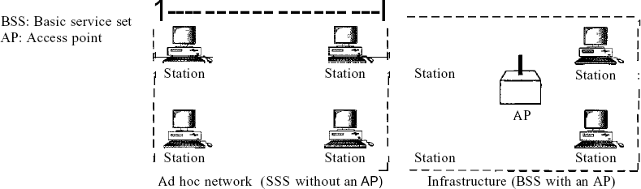

Figure.9Basicservicesets (BSSs)
ExtendedServiceSet
An extended service set (ESS) is made up of two or more BSSs with APs. In this case, the BSSs are connected through a distribution system, which is usually a wired LAN. The distributionsystemconnectstheAPsintheBSSs.IEEE802.11doesnotrestrictthedistributionsystem;it can be any IEEE LAN such as an Ethernet. Note that the extended service set uses two types of stations: mobile and stationary. The mobile stations are normal stations inside a BSS. The stationary stations are AP stations that are part of a wired LAN. Figure 10 shows an ESS.
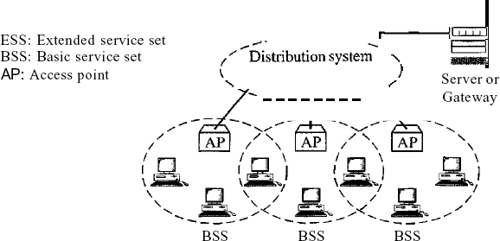
Figure10Extendedservicesets(ESSs)

Bluetooth:

BluetoothisawirelessLANtechnology designedtoconnectdevicesofdifferent functionssuchastelephones, notebooks,computers(desktopandlaptop),cameras, printers, coffee makers, and so on.A Bluetooth LAN is an ad hoc network,which means that the networkis formed spontaneously; the devices, sometimes called gadgets, find each other and make a network called a piconet. A Bluetooth LAN can even be connected to the Internet if one of the gadgets has this capability. A Bluetooth LAN, by nature, cannot be large. If there are manygadgets that try to connect, there is chaos.
Bluetooth technology has several applications. Peripheral devices such as a wireless mouse or keyboard can communicate with the computer through this technology. Monitoring devices can communicatewithsensor devicesinasmallhealthcare center.Home security devicescan use this technology to connect different sensors to the main security controller. Conference attendees can synchronize their laptop computers at a conference.
Bluetooth was originally started as a project by the Ericsson Company. It is named for Harald Blaatand, the king of Denmark (940-981) who united Denmark and Norway.Blaatandtranslatesto Bluetooth in English.
Today, Bluetooth technology is the implementation of a protocol defined by the IEEE 802.15 standard. The standard defines a wireless personal-area network (PAN) operable inan area thesize of a room or a hall.
Architecture
Bluetooth definestwo typesofnetworks:piconetandscatternet.
Piconets
A Bluetooth network iscalled a piconet, or a small net. A piconet can have up to eightstations, one of which is called the primary;t the rest are called secondaries. All the secondary stations synchronize their clocks and hopping sequence with the primary.Note that a piconet can haveonly oneprimarystation.Thecommunicationbetweentheprimaryandthesecondarycanbe one-to-one or one-to-many. Figure 1 shows a piconet.

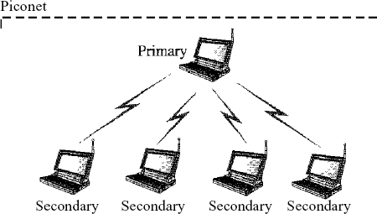

Figure 1Piconet

Although a piconetcanhave a maximum ofseven secondaries,anadditional eightsecondaries can be in the parked state. A secondary in a parked state is synchronized with the primary, but cannot take part in communication until it is moved from the parked state. Because only eight stations can be active in a piconet, activating a station from the parked state means that an active station must go to the parked state.
Scat/ernet
Piconets can be combined to form what is called a scatternet. A secondary station in one piconet can be the primary in another piconet. This station can receive messages from the primary in the first piconet (as a secondary) and, acting as a primary, deliver them to secondaries in the second piconet. A station can be a member of two piconets.
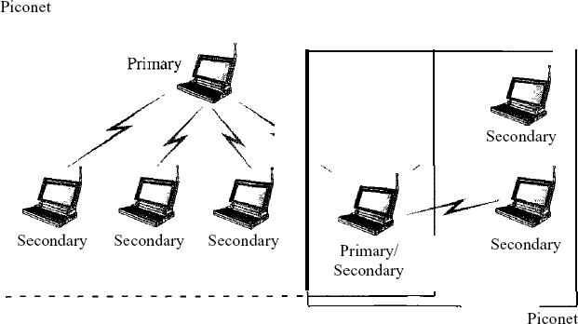

Figure2illustrates ascatternet.

BluetoothDevices
A Bluetooth device has a built-in short-range radio transmitter. The current data rate is 1 Mbps witha2.4-GHzbandwidth.Thismeansthatthere isapossibility ofinterferencebetweenthe IEEE 802.11b wireless LANs and Bluetooth LANs.
BluetoothLayers
Bluetooth uses several layers that do not exactly match those of the Internet model we have defined in this book. Figure 3 shows these layers.
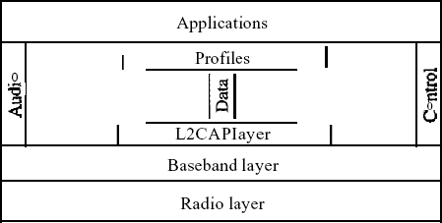

Figure3Bluetoothlayers
RadioLayer
TheradiolayerisroughlyequivalenttothephysicallayeroftheInternetmodel.Bluetooth devices are low-power and have a range of 10 m.
Band
Bluetooth usesa2.4-GHzISMband divided into79channels of1MHzeach.
FHSS
Bluetooth uses the frequency-hopping spread spectrum (FHSS) method in the physical layer to avoid interference from other devices or other networks. Bluetooth hops 1600 times per second, which means that each device changes its modulation frequency 1600 times per second. A device uses a frequency for only 625 Ils (1/1600 s) before it hops to another frequency; the dwell time is 625 Ils.

Modulation
To transform bits to a signal, Bluetooth uses a sophisticated version of FSK, called GFSK (FSK with Gaussian bandwidth filtering; a discussion of this topic is beyond the scope of this book). GFSK has a can'ier frequency. Bit 1 is represented bya frequency deviation above the carrier; bit ais represented by a frequency deviation below the carrier. The frequencies, in megahertz, are defined according to the following formula for each channel:
fc=2402+nn=0,1,2,3,...,78
For example, the first channel uses carrier frequency 2402 MHz (2.402 GHz), and the second channel uses carrier frequency 2403 MHz (2.403 GHz).
BasebandLayer
The baseband layer is roughly equivalent to the MAC sublayer in LANs. The access method is TDMA (see Chapter 12). The primary and secondary communicate with each other using time slots. The length of a time slot is exactly the same as the dwell time, 625 Ils. This means that during the time that one frequencyis used, a sender sends a frame to a secondary, or a secondary sends a frame to the primary. Note that the communication is only between the primary and a secondary; secondaries cannot communicate directly with one another.
TDMA
BluetoothusesaformofTDMA(seeChapter12)thatiscalledTDD-TDMA(timedivision duplexTDMA).TDD-TDMAisakindofhalf-duplexcommunicationinwhichthesecondary and receiver send and receive data, but not at the same time (halfduplex); however, the communication for each direction uses different hops. This is similar to walkie-talkies using different carrier frequencies.
Single-Secondary Communication If the piconet has only one secondary, the TDMA operation is verysimple. The time is divided into slots of 625 Ils. The primary uses evennumberedslots (0, 2, 4, ...); the secondary uses odd-numbered slots (1,3, 5, ...). TDD-TDMA allows the primary andthe secondary to communicate in half-duplex mode.
In slot 0, the primary sends, and the secondary receives; in slot 1, the secondary sends, and the primary receives. The cycle is repeated. Figure 4 shows the concept.

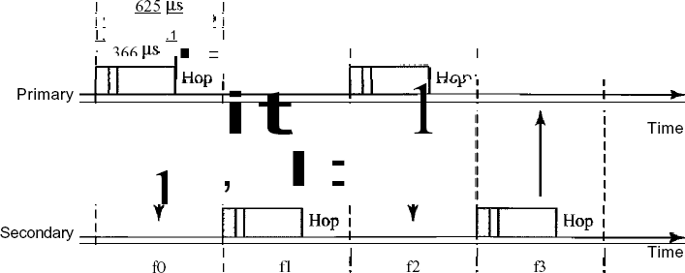

Figure 4Single-secondarycommunication

DataLink LayerSwitching

Bridges:
Many organizations have multiple LANs and wish to connect them. LANs can be connected by devices called bridges, which operate in the data link layer. Bridges examine the data layer link addresses to do routing. Some common situations in which bridges are used.
First,many universityandcorporatedepartmentshavetheirownLANs,primarily toconnect their own personal computers, workstations, and servers. Since the goals of the various departments differ, different departments choose different LANs, without regard to what other departments are doing. Sooner or later, there is a need for interaction, so bridgesare needed.In this example, multiple LANs came into existence due to the autonomy of their owners.
Second, the organization may be geographically spread over several buildings separated by considerable distances. It may be cheaper to have separate LANs in each building and connect them with bridges and laser links than to run a single cable over the entire site.
Third, it may be necessary to split what is logically a single LAN into separate LANs to accommodatetheload.Atmany universities,forexample,thousandsofworkstationsare available for student and faculty computing. Files are normally kept on file server machinesand are downloaded to users' machines upon request. The enormous scale of this system precludes puttingalltheworkstationsonasingleLAN—thetotalbandwidthneededisfartoohigh. Instead, multiple LANs connected bybridges are used, as shown inFig.17.1. EachLANcontainsa cluster of workstations with its own file server so that most traffic is restricted to a single LAN and does not add load to the backbone.
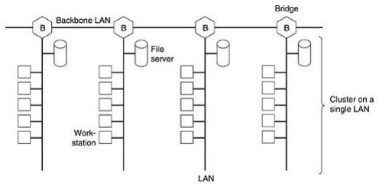

Fig.1 Multiple LANs connected by a backbone to handle a total load higher than thecapacity of a single LAN.

Itisworthnotingthatalthoughweusually drawLANsasmultidropcablesasinFig.1(the classic look), they are more often implemented with hubs or especially switches nowadays. However, a long multi drop cable with multiple machines plugged into it and a hub with the machines connected inside the hub are functionally identical. In both cases, all the machinesbelong to the same collision domain, and all use the CSMA/CD protocol to send frames.
Fourth, in some situations, a single LAN would be adequate in terms of the load, but the physical distance between the most distant machines is too great (e.g., more than 2.5 km for Ethernet).Even if laying the cable is easy to do, the network would not work due to the excessively long round-trip delay. The only solution is to partition the LAN and install bridges between the segments. Using bridges, the total physical distance covered can be increased.
Fifth, there is the matter of reliability. On a single LAN, a defective node that keeps outputting a continuous stream of garbage can cripple the LAN. Bridges can be inserted at critical places, like fire doors in a building, to prevent a single node that has gone berserk from bringing down the entire system. Unlike a repeater, which just copies whatever it sees, a bridge can be programmedto exercise some discretion about what it forwards and what it does not forward.
Sixth, and last, bridges can contribute to the organization's security. Most LAN interfaces have a promiscuous mode, in which all frames are given to the computer, not just those addressed to it. Spies andbusybodies love thisfeature.By inserting bridgesat variousplaces and being careful not to forward sensitive traffic, a system administrator can isolate parts of the network so that its traffic cannot escape and fall into the wrong hands.

OperationofTwo PortBridge:
Fig.2illustratestheoperationofasimple two-portbridge.HostAonawireless(802.11)LAN has a packet to send to a fixed host, B, on an (802.3) Ethernet to which the wireless LAN is connected. The packet descends into the LLC sublayer and acquires an LLC header (shown in blackinthefigure).ThenitpassesintotheMACsublayerandan802.11headerisprependedto it (also a trailer, not shown in the figure). This unit goes out over the air and is picked up by the base station, which sees that it needs to go to the fixed Ethernet.
When it hits the bridge connecting the 802.11 network to the 802.3 network, it starts in thephysicallayerandworksitsway upward.IntheMACsublayerinthebridge,the802.11header is stripped off. The bare packet (with LLC header) is then handed off to the LLC sublayer in the bridge.Inthisexample,thepacketisdestinedforan802.3LAN,soitworksitswaydownthe

802.3 side of the bridge and off it goes on the Ethernet. Note that a bridge connecting k different LANswillhavekdifferentMACsublayersandkdifferentphysicallayers,oneforeachtype.
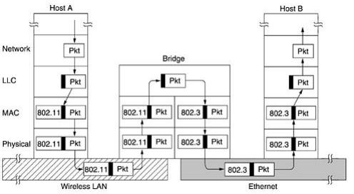

Fig.2 Operationofa LANbridgefrom802.11to 802.3 SpanningTreeBridges:
To increase reliability, some sites use two or more bridges in parallel between pairs of LANs, is shown in Fig.3. This arrangement, however, also introduces some additional problems because it creates loopsin the topology.A simple example of these problems can be seen by observing howa frame, F, with unknown destination is handled in Fig.17.3. Each bridge, following the normal rulesforhandlingunknowndestinations,usesflooding,whichinthisexamplejustmeans copying it to LAN 2. Shortly thereafter, bridge 1 sees F2, a frame with an unknown destination, which it copies to LAN 1, generating F3 (not shown). Similarly, bridge 2 copies F1 to LAN 1 generating F4(also notshown). Bridge 1 nowforwards F4 and bridge 2 copies F3. This cycle goes on forever.
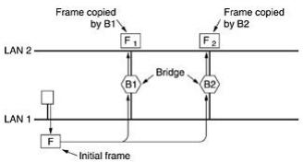

Fig.3.Twoparallel transparentbridges.

The solution to this difficulty is for the bridges to communicate with each other and overlay the actual topology witha spanning tree that reachesevery LAN.Ineffect, somepotential connections between LANs are ignored in the interest of constructing a fictitious loop-free topology. For example, in Fig.4 (a) we see nine LANs interconnected by ten bridges. This configurationcanbeabstractedintoagraphwiththeLANsasthenodes.Anarcconnectsany two LANs that are connected by a bridge. The graph can be reduced to a spanning tree bydropping the arcs shown as dotted lines in Fig.4 (b). Using this spanning tree, there is exactly one path from every LAN to everyother LAN. Once the bridges have agreed on the spanning tree, all forwarding between LANs follows the spanning tree.Since there is a unique path from eachsource to each destination, loops are impossible.
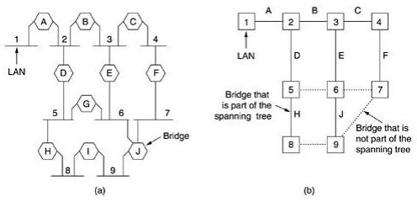

Fig.4 (a) Interconnected LANs. (b) A spanning tree covering the LANs. The dotted lines are not part of the spanning tree.
To build the spanning tree, first the bridges have to choose one bridge to be the root of the tree. They make this choice by having each one broadcast its serial number, installed by the manufacturer and guaranteed to be unique worldwide. The bridge with the lowest serial number becomes the root. Next, a tree of shortest paths from the root to every bridge and LAN is constructed. This tree is the spanning tree. If a bridge or LAN fails, a new one is computed.
The result of this algorithm is that a unique path is established from every LAN to theroot and thustoeveryotherLAN.AlthoughthetreespansalltheLANs,notallthebridgesare necessarily present in the tree(to prevent loops).Even after the spanning tree has been established, the algorithm continues to run during normal operation in order to automaticallydetect topology changes and update the tree.

RemoteBridges:
A common use of bridges is to connect two (or more) distant LANs. For example, a company might have plants in several cities, each with its own LAN. Ideally, all the LANs should be interconnected, so the complete system acts like one large LAN. This goal can be achieved by putting a bridge on each LAN and connecting the bridges pairwise with point-to-point lines (e.g., linesleasedfromatelephonecompany).Asimplesystem,withthreeLANs,isillustratedin Fig.5. The usual routing algorithms apply here. The simplest way to see this is to regard the three point-to-pointlinesashostlessLANs.ThenwehaveanormalsystemofsixLANS interconnected by four bridges.
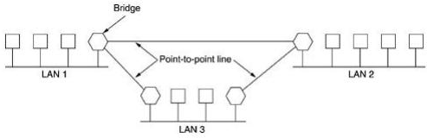

Fig.5.Remote bridges canbe usedtointerconnectdistant LANs.
Various protocols can be used on the point-to-point lines. One possibility is to choose some standard point-to-point data link protocol such as PPP, putting complete MAC frames in the payload field. This strategy works best if all the LANs are identical, and the only problem isgettingframestothecorrectLAN.AnotheroptionistostripofftheMACheaderandtrailerat the source bridge and put what is left in the payload field of the point-to-point protocol. A new MAC header and trailer can then be generated at the destination bridge. A disadvantage of this approach is that the checksum that arrives at the destination host is not the one computed by the source host, so errors caused by bad bits in a bridge's memory may not be detected.

VirtualLANs
A station is considered part of a LAN if it physically belongs to that LAN. The criterion of membership is geographic. What happens if we need a virtual connection between two stations belonging to two different physical LANs? We can roughly define a virtual local area network (VLAN) as a local area network configured by software, not by physical wiring.

Let us use an example to elaborate on this definition. Figure 6 shows a switched LAN in an engineeringfirminwhich10stationsaregroupedintothreeLANsthatareconnectedby a switch. The first four engineers work together as the first group, the next three engineers work together as the second group, and the last three engineers work together as the third group. The LAN is configured to allow this arrangement.
But what would happen if theadministrators needed to move two engineersfromthe firstgroupto the third group, to speed up the project being done by the third group?
The LAN configuration would need to be changed. The network technician must rewire. The problem isrepeatedif,inanotherweek, thetwoengineersmovebacktotheirpreviousgroup.In aswitchedLAN,changesintheworkgroupmeanphysicalchangesinthenetwork configuration.
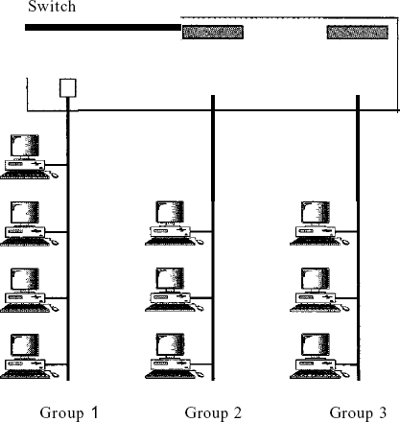
Figure6AswitchconnectingthreeLANs

